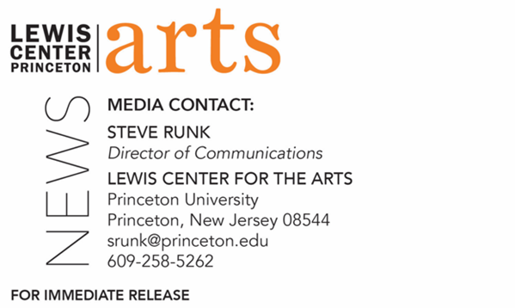

March 1, 2022

Princeton University’s Lewis Center for the Arts presents
“Freedom to Write”
The 2021-2022 Atelier at Large series continues with a conversation with Joy Harjo, Suzanne Nossel, Lynn Nottage, and Paul Muldoon discussing various concepts of freedom in art

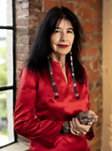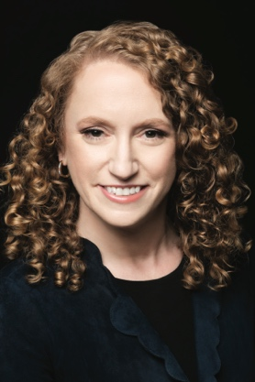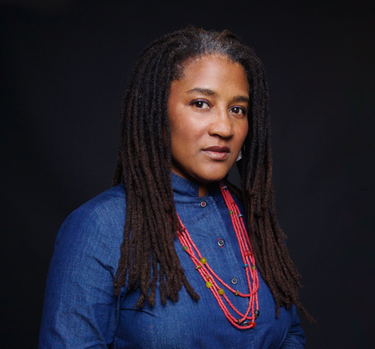

Photo Caption (left): Joy Harjo
Photo Credit (left): Makita Wilbur
Photo Caption (middle): Suzanne Nossel
Photo Credit (middle): Beowulf Sheehan
Photo Caption (right): Lynn Nottage
Photo Credit (right): Lynn Savarse

Who/What: Atelier at Large Series presents “Freedom to Write.” In the latest of a series of conversations that bring guest artists to campus to discuss the challenges they face in making art in the modern world, Princeton Professor Paul Muldoon is joined by the United States Poet Laureate Joy Harjo (When the Light of the World was Subdued, Our Songs Came Through), the CEO of PEN America Suzanne Nossel (Dare to Speak: Defending Free Speech for All), and the Pulitzer Prize-winning playwright Lynn Nottage (Clyde’s, Intimate Apparel, MJ: The Musical). Presented by the Princeton Atelier.
When: Tuesday, March 15, at 7:30 p.m.
Where: Richardson Auditorium on the Princeton University campus
Admission: Free and open to the public. Tickets are required though University Ticketing at tickets.princeton.edu. All guests are required to be fully vaccinated against COVID-19 to the maximum extent, which now includes a COVID booster shot for all eligible to receive it, and to wear a mask when indoors. Please note that speakers may be unmasked while presenting.
Accessibility: Guests in need of access accommodations are asked to contact the Lewis Center at LewisCenter@princeton.edu at least one week prior to the event date.
For more information: https://arts.princeton.edu/events/atelier-at-large-freedom-to-write/

PRINCETON, NJ – Princeton University’s Lewis Center for the Arts presents “Freedom to Write,” next in the Atelier at Large series of conversations that bring guest artists to campus to discuss the challenges they face in making art in the modern world. For this conversation, Princeton’s Howard G.B. Clark ’21 University Professor in the Humanities and Director of the Princeton Atelier Paul Muldoon will be joined by the United States Poet Laureate Joy Harjo, the CEO of PEN America Suzanne Nossel, and the Pulitzer Prize-winning playwright Lynn Nottage to discuss various concepts of freedom. The event begins at 7:30 p.m. on Tuesday, March 15, in the Richardson Auditorium on Princeton’s campus. The event is free and open to the public, but tickets are required through University Ticketing at tickets.princeton.edu. All guests are required to be fully vaccinated against COVID-19 to the maximum extent, which now includes a COVID booster shot for all eligible to receive it, and to wear a mask when indoors. Please note that speakers may be unmasked while presenting.

The Princeton Atelier, currently directed by Muldoon, was founded in 1994 by Toni Morrison, Nobel Laureate and Robert F. Goheen Professor in the Humanities, Emeritus, at Princeton University. The Atelier brings professional artists from different disciplines together with Princeton faculty and students to create new work in the context of a semester-long course that culminates in the public presentation of the new work. Previous artists have included the choreographer Jacques d’Amboise, the cellist Yo-yo Ma, and the novelists Gabriel García Márquez, Rick Moody, and Meg Wolitzer among many others. The Atelier at Large series is an extension of the Princeton Atelier that brings guest artists to campus to speak on themes, questions, and possibilities of arts’ role in the modern world.

Joy Harjo, the 23rd United States Poet Laureate, was born in Tulsa, Oklahoma, and is a member of the Mvskoke Nation. Harjo is the author of nine books of poetry, including An American Sunrise (2019), which was a 2020 Oklahoma Book Award Winner; Conflict Resolution for Holy Beings (2015), which was shortlisted for the Griffin Prize and named a Notable Book of the Year by the American Library Association; and In Mad Love and War (1990), which received an American Book Award and the Delmore Schwartz Memorial Award. Her other poetry awards include the Ruth Lily Prize for Lifetime Achievement from the Poetry Foundation, the Academy of American Poets Wallace Stevens Award, the New Mexico Governor’s Award for Excellence in the Arts, a Rasmuson U.S. Artist Fellowship, two National Endowment for the Arts fellowships, and a Guggenheim Fellowship, among others. Harjo’s first memoir, Crazy Brave (2012), was awarded the PEN USA Literary Award in Creative Non-Fiction and the American Book Award, and her second, Poet Warrior: A Memoir, was released in fall of 2021. Harjo is also the author of two award-winning children’s books, The Good Luck Cat and For a Girl Becoming, as well as a collaboration with photographer/astronomer Stephen Strom; an anthology for North American Native women’s writing; several screenplays and collections of prose interviews; and three plays, including her one-woman show, Wings of Night Sky Wings of Morning Light, A Play. In addition to serving as a three-term U.S. Poet Laureate, Harjo is a chancellor of the Academy of American Poets, directs For Girls Becoming, an arts mentorship program for young Mvskoke women, and is a founding board member and Chair of the Native Arts and Cultures Foundation.

Suzanne Nossel is chief executive officer at PEN America and author of Dare to Speak: Defending Free Speech for All (2020). Prior to joining PEN America, Nossel served as the chief operating officer of Human Rights Watch and as executive director of Amnesty International U.S.A. She has served in the Obama administration as deputy assistant secretary of state for international organizations, leading U.S. engagement in the U.N. and multilateral institutions on human rights issues, and in the Clinton administration as deputy to the U.S. ambassador for U.N. management and reform. Nossel coined the term “Smart Power,” which was the title of a 2004 article she published in Foreign Affairs Magazine and later became the theme of Secretary of State Hillary Clinton’s tenure in office. Nossel is a featured columnist for Foreign Policy Magazine and has published op-eds in The New York Times, The Washington Post, and Los Angeles Times, as well as scholarly articles in Foreign Affairs, Dissent, and Democracy, among others. Nossel is a member of the Oversight Board, an international body that oversees content moderation on social media. She is a former senior fellow at the Century Foundation, the Center for American Progress, and the Council on Foreign Relationship. Nossel is a magna cum laude graduate of both Harvard College and Harvard Law School.

Lynn Nottage is the first and only woman in history to win two Pulitzer Prizes for Drama. Her plays have been produced widely in the United States and throughout the world. Nottage’s recent work includes the libretto for the opera adaption of her play Intimate Apparel, commissioned by the Met at Lincoln Center; the libretto for MJ: the Musical, directed by Christopher Wheeldon at the Neil Simon Theater on Broadway; and Clyde’s, directed by Kate Whoriskey at Second Stage Theater on Broadway. Nottage’s other works include Floyd’s (retitled Clyde’s), which is a musical adaptation of the novel The Secret Life of Bees, performed at the Atlantic Theater; and Mlima’s Tale, performed at The Public Theater. Nottage’s play Sweat won the 2017 Pulitzer Prize for Drama, an Obie Award for Playwriting, the Evening Standard Theatre Award for Best Play, and the Susan Smith Blackburn Prize. Her play Ruined won the 2019 Pulitzer Prize, an Obie Award for Best New American Play, the Lucille Lortel Award for Outstanding Play, the Drama Desk Award for Outstanding Play, and the Outer Critics Circle Award for New Off-Broadway Play, among others. Nottage’s play Intimate Apparel won the 2004 Steinberg New Play Award, presented by the American Theatre Critics, and the New York Drama Critics' Circle Award for Outstanding Off-Broadway Play. Additionally, Nottage is a writer and producer of She's Gotta Have It (Netflix), and a consulting producer on Dickinson (Apple TV+). Nottage’s other awards include a PEN/Laura Pels Master Dramatist Award, Doris Duke Artist Award, American Academy of Arts and Letters Award, MacArthur “Genius Grant” Fellowship, and a Lilly Award for her play By the Way, Meet Vera Stark. Nottage is an associate professor at Columbia University School of the Arts and is a member of the Dramatists Guild.

Paul Muldoon is the Howard G.B. Clark ’21 University Professor in the Humanities at Princeton, as well as the founding chair of the Lewis Center for the Arts. As an internationally renowned Irish poet, Muldoon has been described by The Times Literary Supplement as “the most significant English-language poet born since the second World War.” Muldoon won the Pulitzer Prize for his ninth collection of poems, Moy Sand and Gravel (2002). Additionally, Muldoon has won the 1994 T.S. Eliot Prize, the 2003 Griffin International Prize for Excellence in Poetry, the 2004 Shakespeare Prize, and the 2006 European Prize for Petry, among others. His fourteenth volume of poems, Howdie-Skelp, was released in November 2021 by Farrar Straus & Giroux. Muldoon is the editor of the recently released Paul McCartney boxed, two-volume set, The Lyrics:1956 to the Present, illuminating the stories behind 154 of McCartney’s song lyrics.

The Atelier at Large series will conclude later this spring with a final event.

To learn more about the Princeton Atelier, the Lewis Center for the Arts, and the more than 100 public performances, exhibitions, readings, screenings, concerts, lectures, and special events presented by the Lewis Center each year, most of them free, visit arts.princeton.edu.

# # #

