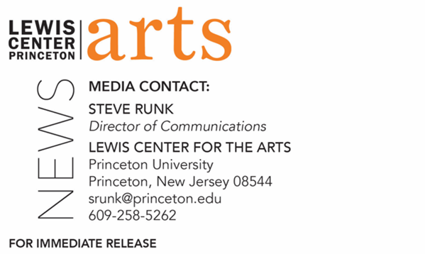

February 11, 2022

Lewis Center for the Arts’ Program in Creative Writing presents a reading by
Garrett Hongo and Gish Jen
Award-winning writers continue the Althea Ward Clark W’21 Reading Series at Princeton

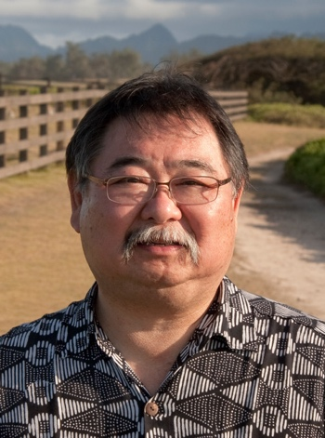  Photo Caption: Garrett Hongo  Photo Credit: Franco Salmoiraghi | 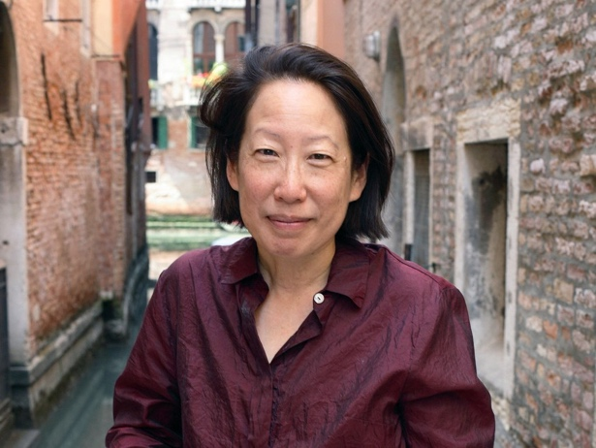  Photo Caption: Gish Jen  Photo Credit: Basso Cannarsa

What/Who: The Althea Ward Clark W’21 Reading Series continues in-person with a reading by Pulitzer Prize-nominated memoirist and poet Garrett Hongo and Lannan Literary Award-winning writer Gish Jen, presented by the Lewis Center for the Arts’ Program in Creative Writing at Princeton University.
When: Tuesday, February 22 at 7:30 p.m.
Where: Hearst Dance Theater at the Lewis Arts complex on the Princeton University campus.
Admission: Free and open to the public. All guests are required to be fully vaccinated against COVID-19 to the maximum extent, which now includes a COVID booster shot for all eligible to receive it, and to wear a mask when indoors. Advance tickets are required and can be reserved through University Ticketing at tickets.princeton.edu
Accessibility: This event will be open captioned, and the venue is wheelchair accessible. Guests in need of other access accommodations are asked to contact the Lewis Center at least one week in advance at LewisCenter@princeton.edu.
For more information: https://arts.princeton.edu/events/reading-by-gish-jen-and-garrett-hongo/

PRINCETON, NJ – The Althea Ward Clark W’21 Reading Series, presented by the Lewis Center for the Arts’ Program in Creative Writing at Princeton University, continues in-person with a reading by Pulitzer Prize-nominated memoirist and poet Garrett Hongo and Lannan Literary Award-winning writer Gish Jen. The reading will take place on Tuesday, February 22 at 7:30 p.m. in the Hearst Dance Theater in the Lewis Arts complex on the Princeton campus. The event is free and open to the public, however, advance tickets are required through University Ticketing at tickets.princeton.edu. All guests are required to be fully vaccinated against COVID-19 to the maximum extent, which now includes a COVID booster shot for all eligible to receive it, and to wear a mask when indoors. This event will be open captioned, and the venue is wheelchair accessible. Guests in need of other access accommodations are invited to contact the Lewis Center at least one week in advance at LewisCenter@princeton.edu.

Garrett Hongo was born in Volcano, Hawai’i, and grew up on the North Shore of O’ahu and in Los Angeles. His collection of poems, The River Heaven (1988), received the Lamont Poetry Prize and was a finalist for a Pulitzer Prize. In his most recent memoir, The Perfect Sound: A Memoir in Stereo (Pantheon 2022), Hongo explores the sounds and music that shaped his life and helped him discover his poetic voice, beginning with Hawai’i’s crashing surf, on to the search for the perfect record player for Puccini’s soprano arias, and finally to the pulse of John Coltrane’s jazz and Billy Joel’s piano cruising down the freeways as a young man in Los Angeles. Hongo told Gale’s Contemporary Authors, “I write to be a voice that I can listen to, one that makes sense and raises my own consciousness. And I write for all the people who might want the same thing, no matter what race, class, or nationality.” His other works include The Mirror Diary: Selected Essays (University of Michigan Press, 2017) and Coral Road: Poems (Knopf, 2013), among others. Hongo was a recipient of a Fulbright Fellowship, two Rockefeller Foundation Fellowships, the Oregon Book Award for nonfiction for his book Volcano: A Memoir of Hawai’i (1995), and a National Endowment for the Arts Fellowship. Currently, Hongo is working on his next collection of poems, The Ocean of Clouds, and is teaching at the University of Oregon as a distinguished professor of arts and sciences.

Gish Jen’s most recent novel, The Resisters (Penguin Random House 2020), follows Gwen, a pitching prodigy in an illegal, underground baseball league, as she challenges a dystopian American government using artificial intelligence and surveillance to enforce a new Jim Crow. The New York Times praised it as “intricately imagined,” and a novel that “grows directly out of the soil of our current political movement.” Jen is also a nonfiction author, and in her book The Girl at the Baggage Claim: Explaining the East-West Culture Gap, she examines the different ideas Eastern and Western cultures have about self and society. Jen’s short stories have been published in The New Yorker, The Atlantic Monthly, as well as The Best American Short Stories and The Best American Short Stories of the Century. Her newest book, Thank You, Mr. Nixon, is her first collection of short stories in two decades and explores the lives of everyday citizens in China since the country was opened. Jen has been nominated for a National Book Critics’ Circle Award, had her work featured in a PBS American Masters’ special on the American novel, and is a member of the American Academy of Arts and Sciences. A recipient of Lannan, Fulbright, Radcliffe, Guggenheim, and National Endowment for the Arts fellowships, Jen is currently a visiting professor at Harvard University, where she was asked to give the 2012 William E. Massey, Sr. Lectures in the History of American Civilization.

The Lewis Center’s Program in Creative Writing annually presents the Althea Ward Clark W’21 Reading Series, which provides an opportunity for students, as well as all in the greater Princeton region, to hear and meet the best contemporary writers. The series is organized by Lecturer in Creative Writing and award-winning poet Michael Dickman. All readings are at 7:30 p.m. in venues in the Lewis Arts complex and are free and open to the public. The 2021-2022 series concludes on March 29 with a reading by fiction writer Brontez Purnell and poet Marilyn Nelson.

To learn more about this event, the Program in Creative Writing, and the more than 100 other performances, exhibitions, readings, screenings, concerts, and lectures presented each year by the Lewis Center, most of them free, visit arts.princeton.edu.

# # #

