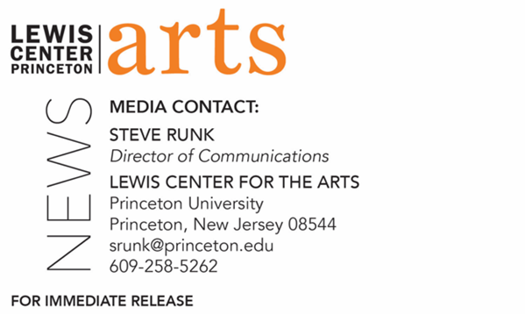
February 14, 2022

Princeton University’s Lewis Center for the Arts and Humanities Council present
Why Do We Do This?
A conversation with Soraya Nadia McDonald and Dexter Thomas about finding purpose and passion in theater in a world where history keeps repeating itself, with a look at 1921, 2021, and beyond

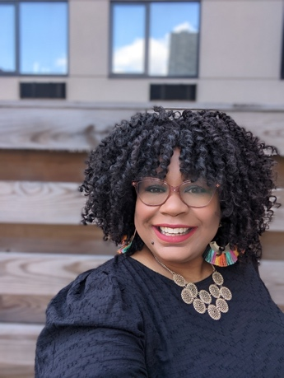  Photo Caption: Soraya Nadia McDonald  Photo Credit: Courtesy of McDonald | 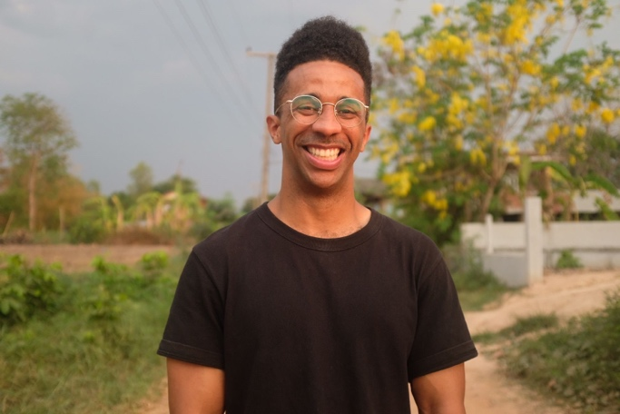Photo Caption: Dexter Thomas  Photo Credit: Karen Ye

Who/What: Why Do We Do This? is the question at the heart of a conversation with award-winning cultural critic and Princeton Belknap Fellow Soraya Nadia McDonald and Dexter Thomas, ACLS (American Council of Learned Societies) Emerging Voices Fellow and Postdoctoral Research Associate in Princeton’s Humanities Council. The discussion will explore finding purpose and passion in theater in a world where history keeps repeating itself, with a look at 1921, 2021, and beyond. This conversation continues themes from the fall 2021 centennial symposium, Reactivating Memory: Shuffle Along and the Tulsa Race Massacre, which examined these seemingly disparate events in 1921 and what can be learned from them today.
When: February 22 at 4:30 p.m.
Where: Online via Zoom Webinar
Admission: Free and open to the public. Zoom registration required.
Accessibility: This event will have live captioning via Zoom. Guests in need of other access accommodations are asked to contact the Lewis Center at LewisCenter@princeton.edu at least one week prior to the event date.
For more information and the Zoom registration link: https://arts.princeton.edu/events/why-do-we-do-this-a-conversation-with-soraya-nadia-mcdonald-and-dexter-thomas/

PRINCETON, NJ – The Lewis Center for the Arts at Princeton University, in collaboration with Princeton’s Humanities Council, presents Why Do We Do This?, a conversation with award-winning cultural critic and Princeton Belknap Fellow Soraya Nadia McDonald and Dexter Thomas, ACLS (American Council of Learned Societies) Emerging Voices Fellow and Postdoctoral Research Associate in the Humanities Council. This conversation will explore finding purpose and passion in theater in a world where history keeps repeating itself, with a look at 1921, 2021, and beyond. The discussion continues themes from the fall 2021 centennial symposium, Reactivating Memory: Shuffle Along and the Tulsa Race Massacre, which examined these seemingly disparate events in 1921 and what can be learned from them today. The conversation will be held on February 22 at 4:30 p.m. via Zoom Webinar and is open to all; advance Zoom registration is required. This event will be live captioned via Zoom. Guests in need of other access accommodations are asked to contact the Lewis Center at LewisCenter@princeton.edu at least one week prior to the event date.

Soraya Nadia McDonald is the award-winning cultural critic for The Undefeated, ESPN’s premiere platform covering race, sports and culture. She writes about film, television and the arts. McDonald is a contributing editor for Film Comment and has contributed criticism for Fresh Air with Terry Gross. Her essay, “‘Believe Me’ Means Believing That Black Women Are People,” was published in Believe Me: How Trusting Women Can Change the World (Seal Press 2020), and her essay, “The Unbearable Whiteness of Oklahoma!,” was published in Bigotry on Broadway (Baraka Books 2021). McDonald was a 2018 Eugene O’Neill National Critics Institute fellow and now serves on the board of trustees. McDonald is a member of the New York Drama Critics’ Circle, the National Society of Film Critics, and the Television Critics Association. McDonald won the 2020 George Jean Nathan prize for dramatic criticism, was a 2020 finalist for the Pulitzer Prize in criticism, and was the runner-up for the 2019 Vernon Jarrett Medal for outstanding reporting on Black life.

Belknap Short-Term Visiting Fellows are selected each year by Princeton’s Humanities Council through a nomination process. During intensive three- to five-day visits, these Fellows lecture and participate in classes, colloquia and informal discussions.

Dexter Thomas, a scholar of international music and youth cultures hailing from San Bernardino, California, is a postdoctoral research associate in the Princeton Humanities Council. Through a 2021-22 Emerging Voices Fellowship of the American Council of Learned Societies, he is developing audio podcasts to highlight the innovations and collaborations fostered by the Humanities Council. He is the host and producer of If Everybody Knew, a podcast from the Humanities Council. The first episode features the “Reactivating Memory” symposium and focuses on the 1921 musical Shuffle Along. Thomas was a Fulbright Scholar and holds a Ph.D. in Asian Studies from Cornell University, specializing in underground Japanese hip-hop culture. At his alma mater, the University of California, Riverside, he established the world’s largest publicly accessible collection of Japanese hip-hop music and cultural materials. He has worked as an on-camera correspondent for VICE News Tonight, with his documentaries appearing on HBO, VICE TV, and Showtime, covering topics from policing and opioids in the U.S. to hip-hop in China and elections in South Africa. He also hosted and produced RESET, a 10-episode TV series covering the unseen world of video games. Thomas contributed to Pulitzer Prize-winning coverage while at the Los Angeles Times, won a Los Angeles Press Club Award and is a three-time News Emmy nominee. Thomas has written music appearing on HBO and VICE TV and has performed in small clubs in upstate New York and Tokyo.

Video recordings of the fall’s centennial symposium sessions and related educational resources are available to scholars, professors and teachers.

To learn more about this event, and the over 100 performance, exhibitions, readings, screenings, concerts, and lectures presented each year at the Lewis Center, most of them free, visit arts.princeton.edu.
# # #

