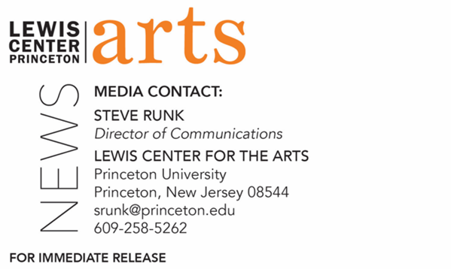

February 3, 2022

Reading by Terese Marie Mailhot and
Princeton Creative Writing Seniors on February 14
Continuing the 2021-2022 C.K. Williams Reading Series organized by
Princeton’s Creative Writing Students

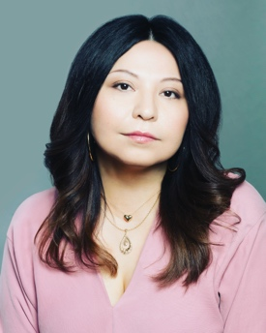
Photo Caption: Terese Marie Mailhot
Photo Credit: Courtesy of Terese Marie Mailhot

What/Who: A reading by writer, journalist and memoirist Terese Marie Mailhot, a First Nations member of Seabird Island Band and winner of a 2019 Whiting Award and a Spalding Prize for the Promotion of Peace and Justice in Literature, and Program in Creative Writing seniors Molly Bremer, Iliyah Coles, Lila Harmar, Megan Pan, Maya Rabinowitz, Grace Xu, and Mina Yu continues the 2021-2022 season of the C.K. Williams Reading Series, presented by the Lewis Center for the Arts’ Program in Creative Writing at Princeton University.
When: Monday, February 14, 2022, at 5:00 p.m.
Where: Drapkin Studio at Lewis Arts complex on the Princeton University campus
Admission: Free and open to the public. All guests are required to be fully vaccinated against COVID-19 to the maximum extent, which now includes a COVID booster shot for all eligible to receive it, and to wear a mask when indoors. Advance tickets are required and can be reserved through University Ticketing at tickets.princeton.edu
Accessibility: Guests in need of access accommodations are invited to contact the Lewis Center at LewisCenter@princeton.edu at least one week in advance of the event date.
For more information: https://arts.princeton.edu/events/c-k-williams-reading-by-terese-marie-mailhot/

PRINCETON, NJ – Award-winning writer, journalist and memoirist Terese Marie Mailhot, a First Nations member of Seabird Island Band, will read from her work at 5:00 p.m. on Monday, February 14 in the Drapkin Studio at the Lewis Arts complex on the Princeton University campus. Joining her will be Molly Bremer, Iliyah Coles, Lila Harmar, Megan Pan, Maya Rabinowitz, Grace Xu, and Mina Yu, seven seniors in Princeton’s Program in Creative Writing, who will also be reading from their recent work; Xu will host the evening. This event is part of the 2021-2022 C.K. Williams Reading Series, named after the late Pulitzer Prize and National Book Award-winning poet C.K. Williams, who served on Princeton’s faculty for 20 years. This series showcases senior thesis students of the Program in Creative Writing alongside established writers as special guests. The event is free and open to the public, however advance tickets are required.

Terese Marie Mailhot is from British Columbia, Canada. Her work has appeared in Elle, Guernica, Time, The Guardian, Mother Jones, Medium, Al Jazeera, the Los Angeles Times, and "Best American Essays," a yearly anthology of essays published by Houghton Mifflin. She is The New York Times bestselling author of Heart Berries: A Memoir (2018). Her book was a finalist for the Governor General's Literary Award for English-Language Nonfiction and was selected by Emma Watson as the Our Shared Shelf Book Club Pick for March/April 2018. Her book was also the January 2020 pick for Now Read This, a book club from PBS Newshour and The New York Times. Heart Berries was also listed as an NPR Best Book of the Year, a Library Journal Best Book of the Year, a New York Public Library Best Book of the Year, a Chicago Public Library Best Book of the Year, and was one of Harper's Bazaar's Best Books of 2018. She is the recipient of a 2019 Whiting Award and is also the recipient of the Spalding Prize for the Promotion of Peace and Justice in Literature. She teaches creative writing at Purdue University.

The seven seniors who will read from their senior thesis projects are among 31 Princeton students pursuing certificates in creative writing in addition to their major areas of study. Each is currently working on a novel, a screenplay, translations, or a collection of poems or short stories as part of a creative thesis for the certificate. Thesis students in the Program in Creative Writing work closely with a member of the faculty, which includes award-winning writers Michael Dickman, Aleksander Hemon, A.M. Homes, Daphne Kalotay, Christina Lazaridi, Jhumpa Lahiri, Yiyun Li, Paul Muldoon, Kirstin Valdez Quade, Susan Wheeler, and a number of distinguished lecturers and visiting professors.

All guests are required to be fully vaccinated against COVID-19 to the maximum extent, which now includes a COVID booster shot for all eligible to receive it, and to wear a mask when indoors. Advance tickets are required and can be reserved through University Ticketing at tickets.princeton.edu. Guests in need of access accommodations are invited to contact the Lewis Center at LewisCenter@princeton.edu at least one week in advance of the event date.

To learn more about the reading series, the Program in Creative Writing, and the more than 100 public performances, exhibitions, readings, screenings, concerts, and lectures presented each year by the Lewis Center for the Arts, most of them free, visit arts.princeton.edu.

# # #

