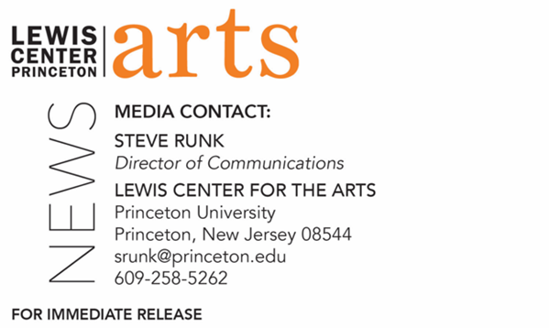

February 28, 2022

Reading by novelist Brandon Taylor and
Princeton Creative Writing Seniors on March 14
Part of the C.K. Williams Reading Series organized by
Princeton’s Creative Writing students

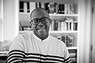
Photo Caption: Novelist Brandon Taylor
Photo Credit: Bill Adams

Who/What: A reading by Brandon Taylor, whose novel Real Life was shortlisted for the 2020 Booker Prize, and eight seniors in the Lewis Center for the Arts’ Program in Creative Writing at Princeton University – Ned Furlong, Christina Im, Makailyn Jones, Maya V. Mishra, Alissa Nalewajko, Noel Peng, Jacqueline Pothier, and Aleeza Schoenberg. The C.K. Williams Reading Series showcases senior thesis students of the Program in Creative Writing with established writers as special guests. Please note that readers may be unmasked while presenting.
When: Monday, March 14, 5:00 p.m.
Where: Drapkin Studio at Lewis Arts complex on the Princeton University campus
Admission: Free and open to the public; tickets required through University Ticketing at tickets.princeton.edu. All guests are required to be fully vaccinated against COVID-19 to the maximum extent, which now includes a COVID booster shot for all eligible to receive it,
and to wear a mask when indoors. Writers may be unmasked while reading.
Accessibility: The venue is wheelchair accessible. Guests in need of access accommodations are asked to contact the Lewis Center at LewisCenter@princeton.edu at least one week prior to the event date.
For more information: https://arts.princeton.edu/events/c-k-williams-reading-by-brandon-taylor/

PRINCETON, NJ – Award-winning novelist Brandon Taylor will read from his work at 5:00 p.m. on Monday, March 14, in-person in the Drapkin Studio in the Lewis Arts complex on the Princeton University campus. Joining him will be Ned Furlong, Christina Im, Makailyn Jones, Maya V. Mishra, Alissa Nalewajko, Noel Peng, Jacqueline Pothier, and Aleeza Schoenberg, eight seniors in Princeton’s Program in Creative Writing, who will also read from their recent work; Princeton senior AG McGee will host the evening. This event is part of the 2021-2022 C.K. Williams Reading Series, named after the late Pulitzer Prize and National Book Award-winning poet C.K. Williams, who served on Princeton’s faculty for 20 years. This series showcases senior thesis students of the Program in Creative Writing alongside established writers as special guests.

This event, presented by the Lewis Center for the Arts, is free and open to the public, however advance tickets are required through University Ticketing at tickets.princeton.edu. All guests are required to be fully vaccinated against COVID-19 to the maximum extent, which now includes a COVID booster shot for all eligible to receive it, and to wear a mask when indoors. Writers may be unmasked while reading.

Brandon Taylor is the author of the novel Real Life, which was a New York Times Editors’ Choice and shortlisted for the 2020 Booker Prize, as well as The National Book Critics Circle John Leonard Prize and the 2021 Young Lions Fiction Award. Newsweek lauds Taylor’s writing style, calling him a “powerhouse” with “tender, intimate and distinctive writing,” and Publishers Weekly praises Taylor’s perspective in Real Life as a “perceptive, challenging exploration of the many kinds of emotional costs [that] will resonate with readers looking for complex characters and rich prose.” His short story collection, Filthy Animals, was published in June 2021 and an instant bestseller, longlisted for the prestigious Dylan Thomas Prize, and named a best book for the year by NPR, Times of London, and Publishers Weekly, among others. Taylor’s other work as an editor and essayist has appeared in Guernica, American Short Fiction, Gulf Coast, Buzzfeed Reader, O: The Oprah Magazine, Gay Mag, The New Yorker online, The Literary Review, and elsewhere. Taylor holds graduate degrees from the University of Wisconsin-Madison and the Iowa Writers’ Workshop, where he was an Iowa Arts Fellow.

The eight seniors, who are pursuing certificates in creative writing in addition to their major areas of study, will read from their senior thesis projects. They are among 31 Princeton seniors who are pursuing certificates in creative writing in addition to their major areas of study. Each is currently working on a novel, a screenplay, translations, or a collection of poems or short stories as part of a creative thesis for the certificate. Thesis students in the Program in Creative Writing work closely with a member of the faculty, which includes award-winning writers Michael Dickman, Aleksander Hemon, A.M. Homes, Daphne Kalotay, Christina Lazaridi, Jhumpa Lahiri, Yiyun Li, Paul Muldoon, Kirstin Valdez Quade, Susan Wheeler and a number of distinguished lecturers and visiting professors.

Guests in need of access accommodations are asked to contact the Lewis Center at LewisCenter@princeton.edu at least one week prior to the event date.

To learn more about the reading series, the Program in Creative Writing, and the more than 100 public performances, exhibitions, readings, screenings, concerts, and lectures presented each year by the Lewis Center for the Arts, most of them free, visit arts.princeton.edu.

# # #

