Media contacts:
Jane Steuerwald, Executive Director  Thomas A. Edison Media Arts Consortium jane@TEFilmFest.org  201-856-6565 | Steve Runk, Director of Communications Lewis Center for the Arts, Princeton University srunk@princeton.edu  609-258-5262

For immediate release

February 9, 2022

Thomas Edison Film Festival
41st Annual Virtual Premiere Screening
Renowned internationally touring film festival kicks off its 2022 season with free online screenings, awards and a talk with filmmakers

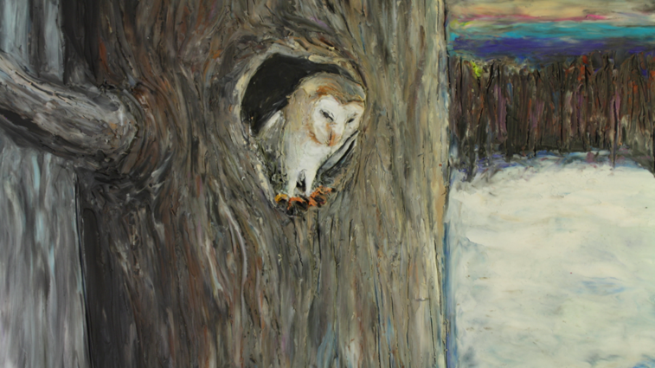
Photo caption: A still from Ten Degrees of Strange, an animated short film by Lynn Tomlinson, one of the works to be screened at the 41st Annual Thomas Edison Film Festival; virtual premiere launching on February 19, 2022.
Photo credit: Courtesy of Lynn Tomlinson
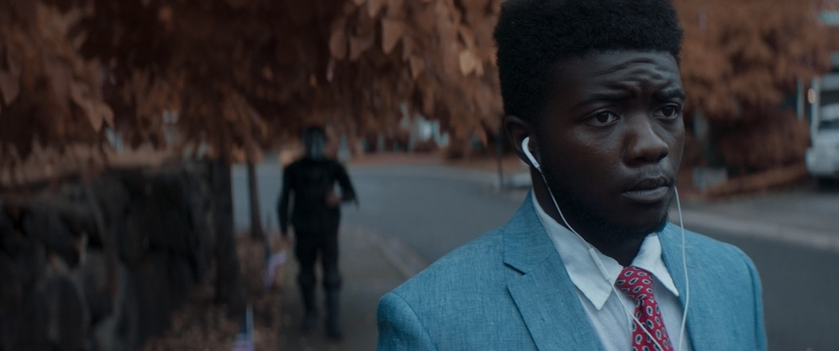
Photo caption: A still from “enough,” an experimental short film by Caleb Slain, Global Insights Stellar Award, to be screened at the 41st Annual Thomas Edison Film Festival virtual premiere on February 19, 2022.
Photo credit: Courtesy of Caleb Slain

What/Who: The 41st season of the renowned Thomas Edison Film Festival (TEFF) will premiere with a virtual screening in collaboration with Princeton University’s Lewis Center for the Arts. Award-winning films representing experimental, animation, documentary, screen dance and narrative genres by Lynn Tomlinson, Joe Quint, Caleb Slain, Zillah Bowes, David De La Fuente, Lisa Fuchs, Richard James Allen, and Karen Pearlman will be available to view for two weeks, from February 12 through February 26, on Vimeo. A live-streamed awards ceremony and panel discussion with filmmakers will be held virtually on Saturday, February 19 at 7:30 p.m. The filmmakers’ panel will be hosted by Festival Director Jane Steuerwald and Festival Associate Henry Baker. NJ State Assemblywoman Lisa Swain will introduce the event. Presented by the Thomas A. Edison Media Arts Consortium and Program in Visual Arts of the Lewis Center for the Arts at Princeton University.
When: Live online event February 19 at 7:30 p.m.; films are available to view on-demand February 12 through February 26
Where: Online via Zoom – no advance registration required. The films will go live on February 12 and will be available to view on-demand at https://vimeo.com/675289843
Admission: Free and open to the public
For more information and Zoom link: https://arts.princeton.edu/events/thomas-edison-film-festival-2022-premiere-screening/

PRINCETON, NJ -- The Thomas Edison Film Festival will kick off its 41st annual season with a virtual screening, a discussion with filmmakers, and presentation of the Edison Innovation Award to Lynn Tomlinson and other filmmaker awards on February 19 at 7:30 p.m. via livestream on Zoom. Following the awards presentation there will be a panel conversation with filmmakers Tomlinson, Joe Quint, David De La Fuente, Zillah Bowes, Lisa Fuchs, Richard James Allen, and Karen Pearlman. Festival Director Jane Steuerwald and Festival Associate Henry Baker will moderate the panel. New Jersey State Assemblywoman Lisa Swain will introduce the event. The award-winning films will be available to view on-demand February 12 through 26 at https://vimeo.com/675289843. The event and films are free and available to the public and presented by the Thomas Edison Media Arts Consortium in collaboration with the Lewis Center for the Arts’ Program in Visual Arts at Princeton University. For the Zoom link to join the live event February 19 and information on the films visit art.princeton.edu; no advance registration required.

The Thomas Edison Film Festival is an international juried competition celebrating all genres and independent filmmakers across the globe. For more than 40 years, the Festival has been advancing the unique creativity and power of the short film by celebrating stories that shine a light on issues and struggles within contemporary society. The Festival was founded in 1981 as Black Maria Film Festival and originally named for Thomas Edison’s West Orange, New Jersey film studio dubbed the “Black Maria” because of its resemblance to the black-box police paddy wagons of the same name. Renamed in 2021, the Festival’s relationship to Thomas Edison’s invention of the motion camera and the kinetoscope and his experimentation with the short film is at the core of the Festival.

The Thomas Edison Media Arts Consortium also showcases the New Jersey Young Filmmakers Festival and the Global Insights Collection, an archive of films focusing on the environment, LGBTQ subjects, people with disabilities, international issues, race and class, and films with themes of social justice.

This is the fourth year the Lewis Center has collaborated with the Consortium to host the Festival premiere. In addition to premiering the season, the Consortium programs other screenings for Princeton audiences and brings Festival filmmakers together with Princeton students and faculty. Princeton 2021 alumnus Alexander Deland, Jr.’s narrative film, On the Sidewalk, at Night, was among the 2022 Festival-selected films earning a Director’s Choice Award. Films by current Princeton undergraduate students Lola Constantino and Dylan Fox received Honorable Mention Awards.

The Festival received 670 submissions for the 2022 season from every continent except Antarctica. Following an extensive pre-screening process by experts in the field of film curation, media studies and production, the highly regarded Festival jurors, Margaret Parsons, Curator Emeritus of Film at the National Gallery of Art in Washington, D.C., and Henry Baker, Emmy Award-winning filmmaker and former director of Synapse Video Center, chose 115 films for the 2022 collection and awarded the top prizes. Following the premiere at Princeton, these films will be made available for screenings in the U.S. and abroad.

The seven prize-winning films being screened for the premiere include:

Ten Degrees of Strange by Lynn Tomlinson of Owings Mills, Maryland, is a music video based on a song by Robert Macfarlane and Johnny Flynn from their album Lost in the Cedar Wood. Taking inspiration from The Epic of Gilgamesh, an ancient story written on clay tablets, and responding to the strangeness of the global pandemic, Tomlinson’s animated film is a story of loss and hope in nature told through colorful, shifting, changing, morphing, clay on glass animation.

Hello Sunshine is a documentary film by Joe Quint of Brooklyn, New York. The protagonist, Roz Pichardo, is more than a domestic violence and gun violence survivor, she’s a warrior. Despite being thrown off a bridge by an abusive ex-boyfriend, the unsolved murder of her brother, and the suicide of her identical twin sister, Roz channels her trauma into service by helping the often-forgotten people of North Philadelphia. Roz gives comfort to families of murder victims and has saved the lives of over 500 men and women in active opioid addiction. Roz knows that her healing and her survival depends upon healing others.

“enough”, by Caleb Slain of Shoreline, Washington, is an experimental film that is simultaneously a dream, a nightmare, and a musical. Shot over 10 years, this surreal hip-hop odyssey unpacks the stormy inner world of Nathan Nzanga, a Congolese American artist coming of age in a fractured nation. The film uses dream logic to sift through Nate's most conflicted feelings about policing, love, and identity in a divided nation.

Allowed is an experimental film by Zillah Bowes of Cardiff, Wales, in the U.K. Bowes frames weeds as friends. During the first Covid-19 wave, plants and flowers were allowed to grow wild. Using 3D animated photos, this film lyrically re-examines our relationship with urban plant life in the urgent context of biodiversity loss and climate crisis.

Compositions for Understanding Relationships by David De La Fuente of New York City is an animated film that takes the shape of a “love letter.” This concept is examined as various forms of relationships are brought on throughout the film. Taken in and out of the romantic context, the viewer gazes upon the dynamic play of color, form, balance, proportion, and unity: “…for the lover the letter has no tactical value: it is purely expressive…”

Rivage (The Shore) by Lisa Fuchs of Paris is a narrative film that speaks to the zone between dry land and water, without precise boundaries. The film depicts this world between life and death, where the borders are porous. A woman, Eva, is drawn to the sea and her body merges with the landscape. Even after Eva’s companion David dies accidentally at sea, the bond between them remains strong through their child that Eva is carrying, Louis. Eva stands between David and Louis – torn between the joy of giving life and the sorrow of her loss. At the end of her mourning process, she chooses life, sublimating her pain through dance.

Digital Afterlives by Richard James Allen and Karen Pearlman of Surry Hills, New South Wales, Australia, is a screen dance in which a man in white-winged angel shoes in an infinite black space is awakened by the strains of Franz Liszt’s “Totentanz” (“The Dance of the Dead”). He is multiplied and manipulated through all the dimensions of infinite black. None of the incarnations of his body have free will as he is thrown, bounced, split, squelched, flopped, frozen, and slid through multitudinous geometries by an unknown force, finally to be returned to his original form and spat out onto the junk heap of history.

Venues interested in scheduling a screening should contact Festival Director Jane Steuerwald at Jane@TEFilmFestival.org. The Festival offers programming options ranging from a custom-curated program to an online film presentation by the Festival director, including a Q & A and dialogue with the audience.

In addition to the support provided for the 2022 season by the Lewis Center for the Arts, the Thomas Edison Film Festival receives support from the New Jersey State Council on the Arts; the Charles Edison Fund – Edison Innovation Foundation; the Hudson County Office of Cultural and Heritage Affairs and Tourism; the Hoboken Historical Museum; Big Sky Edit; Puffin Foundation: WithumSmith+Brown; Lowenstein Sandler, LLP; the NBA; Monster Remotes; Syracuse University; Fairleigh Dickinson University; East Brunswick Tech School of the Arts, Adobe Systems, Inc.; and Microsoft through TechSoup.org.

To learn more about the Thomas Edison Film Festival and Thomas A. Edison Media Arts Consortium, visit www.tefilmfest.org. To learn more about the Lewis Center for the Arts, the premiere screening, and the more than 100 public performances, exhibitions, readings, screenings, concerts and lectures presented each year, most of them free, visit arts.princeton.edu.

# # #

