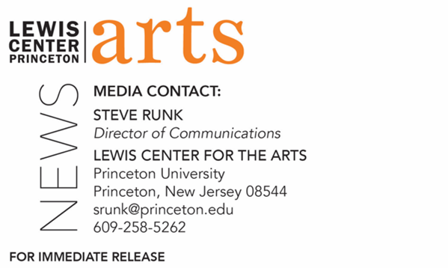

March 10, 2022

Princeton’s Lewis Center for the Arts Atelier at Large Series
presents
Mike Birbiglia Live!
Award-winning comedian, storyteller, director, podcaster, producer, and actor closes
the 2021-2022 series

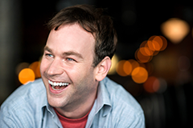
Photo Caption: Comedian, storyteller, director, podcaster, producer, and actor Mike Birbiglia
Photo Credit: Evan Sung

Who/What: Princeton’s Atelier at Large Series presents Mike Birbiglia Live! Mike Birbiglia is a comedian, storyteller, director, podcaster, producer, and actor who has performed in front of audiences worldwide. His solo shows Sleepwalk With Me, My Girlfriend’s Boyfriend, Thank God For Jokes, and his most recent show, The New One, enjoyed successful off Broadway runs. The New One moved to Broadway where he received the Drama Desk Award for outstanding solo performance. The New One and Thank God For Jokes became critically acclaimed Netflix specials. Birbiglia also wrote, directed, and starred in the films Sleepwalk with Me and Don’t Think Twice. His books, Sleepwalk with Me and Other Painfully True Stories and The New One are both national bestsellers. He’s appeared in the films Trainwreck, The Fault in Our Stars and Popstar, as well as TV roles in Orange Is the New Black and Billions. He hosts a podcast, Mike Birbiglia's Working It Out, and is currently touring material from his newest show The Old Man and The Pool. Mike Birbiglia is currently co-teaching the spring Princeton Atelier course, “The Old Man and The Pool: Crafting a Long-form Monologue.” Cosponsored by Princeton’s Office of the Dean for Undergraduate Students.
When: Sunday, April 3, at 7:00 p.m.
Where: Richardson Auditorium, Alexander Hall on the Princeton campus
Admission: Tickets required through University Ticketing at tickets.princeton.edu. Free to Princeton students, $25 for Princeton faculty, staff, and the general public. Ticketing is open to Princeton students and will open to all others starting March 16. All guests are required to be fully vaccinated against COVID-19 to the maximum extent, which now includes a COVID booster shot for all eligible to receive it, and to wear a mask when indoors. The performer may be unmasked when performing on stage.
Accessibility: Guests in need of access accommodations are asked to contact the Lewis Center at LewisCenter@princeton.edu at least one week prior to the event date.
For more information: https://arts.princeton.edu/events/mike-birbiglia-live/

PRINCETON, NJ – Princeton University’s Lewis Center for the Arts presents “Mike Birbiglia Live!” as the final event in the 2021-2022 Atelier at Large series. The event will be held on Sunday, April 3, at 7:00 p.m. in the Richardson Auditorium at Alexander Hall on the Princeton campus. Advance tickets are required through University Ticketing at tickets.princeton.edu; this event is free for Princeton students, and $25 for Princeton faculty, staff, and the general public. All guests are required to be full vaccinated against COVID-19 to the maximum extent, which now includes a COVID booster shot for all eligible to receive it, and to wear a mask when indoors. The performer may be unmasked when performing on stage. Mike Birbiglia Live! is cosponsored by Princeton’s Office of the Dean for Undergraduate Students

Mike Birbiglia is a comedian, storyteller, director, podcaster, producer, and actor who has performed in front of audiences worldwide. His solo shows Sleepwalk With Me, My Girlfriend’s Boyfriend, Thank God For Jokes, and his most recent show, The New One, enjoyed successful off Broadway runs. The New One moved to Broadway where he received the Drama Desk Award for outstanding solo performance. The New One and Thank God For Jokes became critically acclaimed Netflix specials. Birbiglia also wrote, directed, and starred in the films Sleepwalk with Me and Don’t Think Twice. His books, Sleepwalk with Me and Other Painfully True Stories and The New One are both national bestsellers. He’s appeared in the films Trainwreck, The Fault in Our Stars and Popstar, as well as TV roles in Orange Is the New Black and Billions. He hosts a podcast, Mike Birbiglia's Working It Out, and is currently touring material from his newest show The Old Man and The Pool.

Birbiglia is currently co-teaching the spring Princeton Atelier course, “The Old Man and The Pool: Crafting a Long-form Monologue,” with theater director and actor Seth Barrish.
The Princeton Atelier, currently directed by Princeton’s Howard G.B. Clark ’21 University Professor in the Humanities and Pulitzer Prize-winning poet Paul Muldoon, was founded in 1994 by Toni Morrison, Nobel laureate and Princeton’s Robert F. Goheen Professor in the Humanities, Emeritus. The Atelier brings professional artists from different disciplines together with Princeton faculty and students to create new work in the context of a semester-long course. Each course culminates in the public presentation of the new work. Previous artists have included the choreographer Jacques d’Amboise, the cellist Yo-Yo Ma, and the novelists Gabriel García Márquez, Rick Moody, and Meg Wolitzer, among many others. The Atelier at Large series is an extension of the Princeton Atelier that brings guest artists to campus to speak on themes, questions, and possibilities of art’s role in the modern world.

Guests in need of access accommodations at this event are asked to contact the Lewis Center at LewisCenter@princeton.edu at least one week prior to the event date.

To learn more about the Princeton Atelier, the Lewis Center for the Arts, and the more than 100 public performances, exhibitions, readings, screenings, concerts, lectures, and special events presented by the Lewis Center each year, most of them free, visit arts.princeton.edu.

# # #

