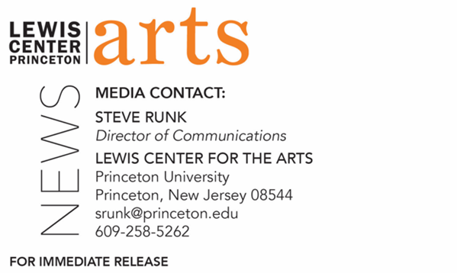

March 8, 2022

Fund for Irish Studies at Princeton University presents
“From Triumphalism to Desperation – the Fall of Ulster Unionism”
Lecture by journalist Susan McKay continues the spring 2021-2022

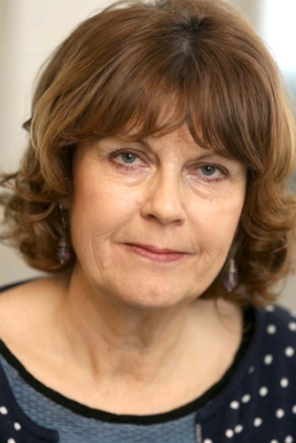
Photo Caption: Journalist Susan McKay
Photo Credit: Derek Speirs

Who/What: In a lecture titled, “From Triumphalism to Desperation – the Fall of Ulster Unionism,” journalist Susan McKay discusses her new book, Northern Protestants - On Shifting Ground. McKay shares that in 2021 unionists in Ireland attempted to celebrate the centenary of Northern Ireland and in 2022 they collapsed its government. Political unionism is hardening into a nostalgia for the sectarian state that the Good Friday Agreement dismantled, but McKay’s book explores the surprising diversity of thought among people from a Protestant background who are impatient with narrowness, open to new ideas and welcoming of the potential for political change.
When: Friday, March 18, at 4:30 p.m.
Where: James Stewart Film Theater at 185 Nassau St.
Admission: Free and open to the public. Advance tickets are required through University Ticketing. All guests must be fully vaccinated against COVID-19 to the maximum extent, which now includes a COVID booster shot for all those eligible to receive it. Additionally, all guests must wear a mask when indoors. Please note that speakers may be unmasked while presenting.
Accessibility: Guests in need of access accommodations are asked to contact the Lewis Center at LewisCenter@princeton.edu at least one week prior to the event date.
For more information: https://arts.princeton.edu/events/fund-for-irish-studies-susan-mckay-on-from-triumphalism-to-desperation-the-fall-of-ulster-unionism/

PRINCETON, NJ – Princeton University’s Fund for Irish Studies presents “From Triumphalism to Desperation – the Fall of Ulster Unionism,” a lecture by journalist Susan McKay, on Friday March 18, at 4:30 p.m. at the James Stewart Film Theater at 185 Nassau Street. Princeton’s Howard G.B. Clark ’21 University Professor in the Humanities and Co-chair of the Fund for Irish Studies Paul Muldoon will provide a welcome and introduction. The event is part of the 2021-2022 lecture series and is free and open to the public. Advance tickets are required through University Ticketing at tickets.princeton.edu. All guests must be fully vaccinated against COVID-19 to the maximum extent, which now includes a COVID booster shot for all those eligible to receive it. Additionally, all guests must wear a mask when indoors. Please note that speakers may be unmasked while presenting. Guests in need of access accommodations are asked to contact the Lewis Center at LewisCenter@princeton.edu at least one week prior to the event date.

McKay will discuss her new book, Northern Protestants - On Shifting Ground (Blackstaff Press 2021), which is a collection of almost 100 interviews with politicians, community workers, religious leaders, former paramilitary members, young people, business people, and other citizens of Northern Ireland from County Antrim to the city of Londonderry, McKay’s hometown. In this follow-up to her book Northern Protestants: An Unsettled People, first published 21 years ago, McKay shares that in 2021 unionists in Ireland attempted to celebrate the centenary of Northern Ireland and then in 2022 they collapsed its government. Political unionism is hardening into a nostalgia for the sectarian state that the Good Friday Agreement dismantled, but McKay’s book explores the surprising diversity of thought among people from a Protestant background who are impatient with narrowness, open to new ideas, and welcoming of the potential for political change. Northern Protestants — On Shifting Ground was described by the Observer as "a fascinating and constantly thought-provoking book" and The Irish Times said it was "vital reading in all senses of the word."

McKay’s journalism has appeared in The New Yorker, The New York Times, London Review of Books, the Guardian/Observer and The Irish Times. McKay is currently writer-in-residence with Sligo Libraries, working on a project about the legacies of the partition of Ireland in the North West. She is also writing a book about borders for which she received an Arts Council of Northern Ireland major individual award.

Paul Muldoon is the Howard G.B. Clark ’21 University Professor in the Humanities at Princeton, as well as the founding chair of the Lewis Center for the Arts. As an internationally renowned Irish poet, Muldoon has been described by The Times Literary Supplement as “the most significant English-language poet born since the second World War.” Muldoon won the Pulitzer Prize for his ninth collection of poems, Moy Sand and Gravel (2002). Additionally, Muldoon has won the 1994 T.S. Eliot Prize, the 2003 Griffin International Prize for Excellence in Poetry, the 2004 Shakespeare Prize, and the 2006 European Prize for Poetry, among others. His fourteenth volume of poems, Howdie-Skelp, was released in November 2021 by Farrar Straus & Giroux. Muldoon is the editor of the recently released Paul McCartney boxed, two-volume set, The Lyrics: 1956 to the Present, illuminating the stories behind 154 of McCartney’s song lyrics.

The Fund for Irish Studies is co-chaired this year by Muldoon and Fintan O’Toole, the Visiting Leonard L. Milberg ’53 Professor in Irish Letters at Princeton, and affords all Princeton students, and the community at large, a wider and deeper sense of the languages, literatures, drama, visual arts, history, and economics not only of Ireland but of “Ireland in the world.” The lecture series is co-produced by the Lewis Center for the Arts.

Information about the Fund for Irish Studies lecture series’ events can be found at fis.princeton.edu. The final event in the 2021-2022 series will feature novelist Danielle McLaughlin on April 8.

The Fund for Irish Studies is generously sponsored by the Durkin Family Trust and the James J. Kerrigan Jr. ’45 and Margaret M. Kerrigan Fund for Irish Studies.

To learn more about the more than 100 public performances, exhibitions, readings, screenings, concerts, lectures, and special events, most of them free, presented each year by the Lewis Center for the Arts, visit arts.princeton.edu.

# # #

