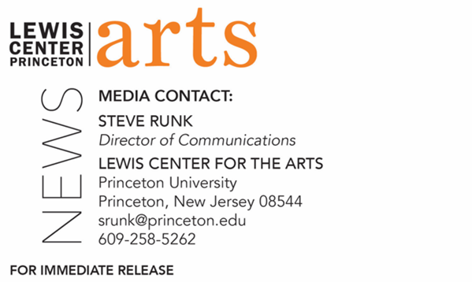

March 9, 2022

Lewis Center for the Arts’ Program in Creative Writing presents
“What it be like? Docupoetics of the Failing Empire”
A reading and meditation with the 2021-2022 Holmes Visiting Professor
Tyehimba Jess
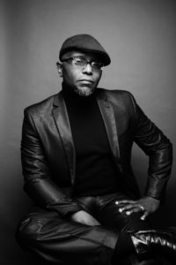
Photo Caption: Pulitzer Prize-winning poet Tyehimba Jess, the 2021-22 Holmes Visiting Professor in Princeton University’s Program in Creative Writing.
Photo Credit: John Midgley

Who/What: Tyehimba Jess, a Pulitzer Prize-winning poet and current Holmes Visiting Professor at Princeton, presents the annual Theodore H. Holmes ’51 and Bernice Holmes Lecture, “What it be like? Docupoetics of the Failing Empire,” a reading and meditation.
When: Wednesday, March 16, at 5:00 p.m.
Where: Wallace Theater at the Lewis Arts complex on the Princeton campus
Admission: Free and open to the public. All guests are required to register for the event beforehand through University Ticketing at tickets.princeton.edu. All guests must be fully vaccinated against COVID-19 to the maximum extent, which now includes a COVID booster shot for all those eligible to receive it. Additionally, all guests must wear a mask when indoors. The speaker may be unmasked while presenting.
Accessibility: Guests in need of access accommodations are asked to contact the Lewis Center at LewisCenter@princeton.edu at least one week prior to the event date.
For more information: https://arts.princeton.edu/events/2021-22-holmes-lecture-tyehimba-jess/

PRINCETON, NJ – The Lewis Center for the Arts’ Program in Creative Writing presents the 2021-2022 Theodore H. Holmes ’51 and Bernice Holmes Lecture by current Holmes Visiting Professor Tyehimba Jess, on Wednesday, March 16, at 5:00 p.m. in the Wallace Theater. This event is free and open to the public; however, advance tickets are required through University Ticketing at tickets.princeton.edu. All guests must be fully vaccinated against COVID-19 to the maximum extent, which now includes a COVID booster shot for all those eligible to receive it. Additionally, all guests must wear a mask when indoors. The speaker may be unmasked while presenting. Guests in need of access accommodations are asked to contact the Lewis Center at LewisCenter@princeton.edu at least one week prior to the event date.

Tyehimba Jess is the author of two books of poetry, Leadbelly and Olio. Olio won the 2017 Pulitzer Prize for Poetry, the Anisfield-Wolf Book Award, the Midland Society Author’s Award in Poetry, and received an Outstanding Contribution to Publishing Citation from the Black Caucus of the American Library Association. Additionally, it was nominated for the National Book Critics Circle Award, the PEN Jean Stein Book Award, and the Kingsley Tufts Poetry Award. Leadbelly won the 2004 National Poetry Series. Both The Library Journal and Black Issues Book Review named it one of the “Best Poetry Books of 2005.” Jess, an alumnus of Cave Canem and New York University, received a 2004 Literature Fellowship from the National Endowment for the Arts and was a 2004–2005 Winter Fellow at the Provincetown Fine Arts Work Center. Jess is also a veteran of the 2000 and 2001 Green Mill Poetry Slam Team and won a 2000–2001 Illinois Arts Council Fellowship in Poetry, the 2001 Chicago Sun-Times Poetry Award, and a 2006 Whiting Fellowship. He presented his poetry at the 2011 TedX Nashville Conference and won a 2016 Lannan Literary Award in Poetry. He was a 2018 Guggenheim Fellow. Jess' fiction and poetry have appeared in many journals, as well as anthologies such as Angles of Ascent: A Norton Anthology of Contemporary African American Poetry, Beyond the Frontier: African American Poetry for the Twenty-First Century, Role Call: A Generational Anthology of Social and Political Black Literature and Art, Bum Rush the Page: A Def Poetry Jam, Power Lines: A Decade of Poetry from Chicago's Guild Complex, and Slam: The Art of Performance Poetry. In addition to his visiting professorship at Princeton, Jess is a professor of English at CUNY College of Staten Island.

To learn more about the more than 100 public performances, exhibitions, readings, screenings, concerts, lectures, and special events, most of them free, presented each year by the Lewis Center for the Arts, visit arts.princeton.edu.

# # #

