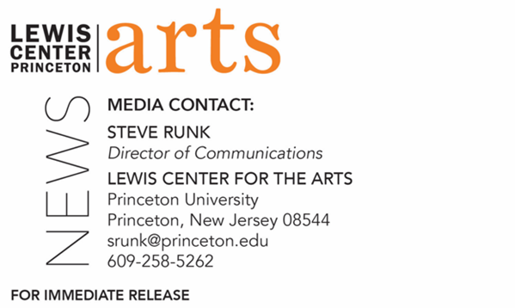

March 7, 2022

Princeton Arts Fellows for 2022-2024 Announced
Choreographer, educator, and disability advocate Christopher “Unpezverde” Núñez
and singer-songwriter-storyteller Kamara Thomas

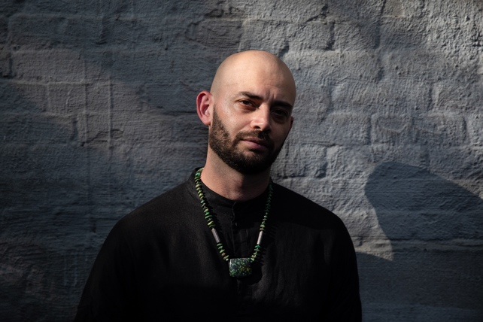  Photo Caption: Christopher “Unpezverde” Núñez  Photo Credit: Walter Wlodarczyk | 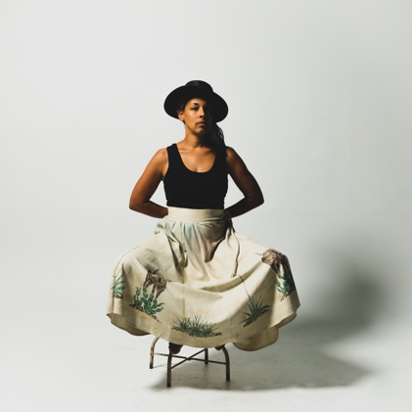  Photo Caption: Kamara Thomas  Photo Credit: Derrick Beasley

PRINCETON, NJ – Choreographer, educator, and disability advocate Christopher “Unpezverde” Núñez and singer-songwriter-storyteller Kamara Thomas have been named Princeton University Arts Fellows for 2022-2024 by the Lewis Center for the Arts and will begin two years of teaching and community collaboration in September.

The Arts Fellows program of the Lewis Center provides support for early-career artists who have demonstrated both extraordinary promise and a record of achievement in their fields with the opportunity to further their work while teaching within a liberal arts context. Funded in part by the Andrew W. Mellon Foundation, the David E. Kelley ’79 Society of Fellows Fund, and the Maurice R. Greenberg Scholarship Fund, fellows are selected for a two-year residency to teach a course each semester or, in lieu of a course, to undertake an artistic assignment that deeply engages undergraduate students, such as directing a play, conducting a musical ensemble, or choreographing a dance piece. Fellows are expected to be active members of the University’s intellectual and artistic community while in residence, and in return, they are provided with the resources and spaces necessary for their work.

The two artists were selected by faculty in the Lewis Center for the Arts and Princeton’s Department of Music from a large, diverse, and multi-talented pool of over 700 applicants in dance, music, creative writing, theater, and the visual arts.

“We had our strongest pool of applicants ever this year, across all disciplines,” notes Stacy Wolf, Director of Fellowships, Professor of Theater, and Director of the Program in Music Theater. “Christopher and Kamara will be phenomenal additions to our community as artists and as teachers, and we’re thrilled to support their work for the next two years.”

Born in Costa Rica, Christopher “Unpezverde” Núñez is a visually impaired choreographer, educator, and accessibility consultant based in New York City. His performances have been presented at The Brooklyn Museum for The Immigrant Artist Biennale, The Kitchen, The Joyce Theater, Danspace Project, Movement Research at The Judson Church, The Leslie-Lohman Museum of Art, Battery Dance Festival, Performance Mix Festival, and Dixon Place, among others. His work has been featured in publications such as The New York Times, The Brooklyn Rail, and The Dance Enthusiast. He has held residencies at Brooklyn Academy of Music (BAM), Danspace Project, The Kitchen, Movement Research, Center for Performance Research, and New Dance Alliance. As a performer, his most recent collaborations include “Dressing Up for Civil Rights” by William Pope L, presented at The Museum of Modern Art. In 2020, Núñez was invited by the New York City Mayor’s Office of Immigrant Affairs to share his story as a disabled and formally undocumented immigrant choreographer during Immigrant Heritage Week. Núñez received his green card in 2018 but continues to advocate for the rights of undocumented and disabled immigrants. He holds a B.F.A. in Science in Performing Arts from the National University of Costa Rica.
Kamara Thomas is a singer, songwriter and multidisciplinary storyteller, and, as she says, “a songspeller and mythology fanatic” based in Durham, North Carolina. Her storytelling is collaborative and multi-faceted, weaving together musical and theater performance, community art-making, ritual, and visual elements including film, masks, archival material and photography. In collaboration with the Denver-based theater company Band of Toughs, Thomas is currently developing “Tularosa: An American Dreamtime,” a storywork based on her 2022 album of the same name, which explores the American psyche through the mythology of the American West. Thomas also spearheads Country Soul Songbook, an artist-centered community and online platform featuring performances, interviews, conversations, and cultural offerings rooted in the mission to amplify historically marginalized voices in Country and Americana music. Thomas has been a featured artist for Lincoln Center Education and was named one of the “14 Artists Proving Black Americana is Real” by Paste Magazine in 2017. Thomas has created commissioned work for Cassilhaus, Duke University, and the University of North Carolina, and she has been a guest speaker at Duke, Princeton, and Indiana Universities.
“Because both Christopher and Kamara are grounded in artistic practices that cherish the relationship between their arts and the communities in which they find themselves,” said Michael Cadden, interim chair of the Lewis Center, “we look forward to the riches they will share with our students at the Lewis Center for the Arts and with the larger community of which we are a part.”

The next round of Fellowship applications will open in July with a mid-September deadline. Guidelines will be posted on the Lewis Center website at arts.princeton.edu. For questions about the Fellowship program, write to lca-fellowships@princeton.edu.

# # #

