Media contacts:
Jane Steuerwald, Executive Director  Thomas A. Edison Media Arts Consortium jane@TEFilmFest.org  201-856-6565 | Steve Runk, Director of Communications Lewis Center for the Arts, Princeton University srunk@princeton.edu  609-258-5262

For immediate release

March 16, 2022

Thomas Edison Film Festival & Lewis Center for the Arts present
Selected short films from the Festival’s 2022 touring collection Featuring award-winning films by recent Princeton alumnus Alexander Deland, Jr. ’21 and current Princeton students Lola Constantino ’23 and Dylan Fox ’22

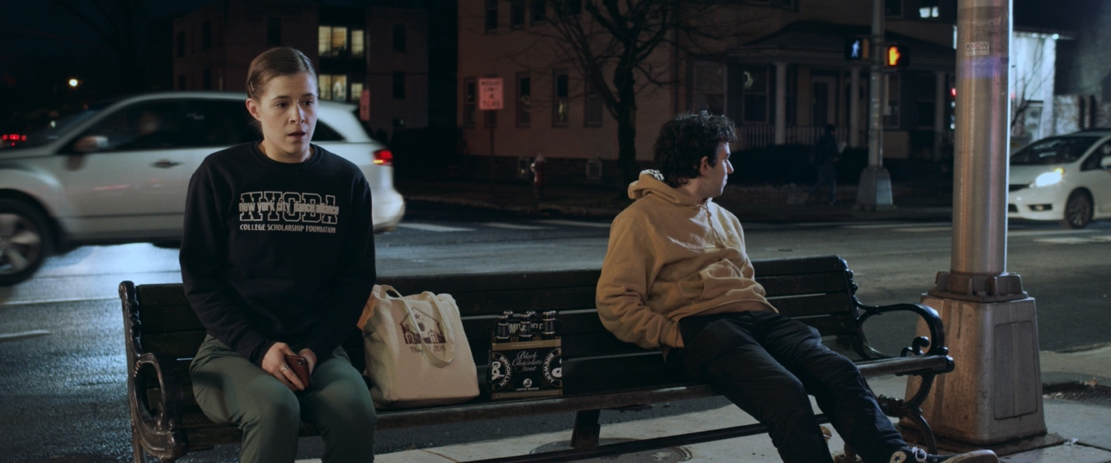Photo caption: A still from On the Sidewalk, at Night, narrative short film by Alexander Deland, Jr., Princeton class of 2021.
Photo credit: Courtesy of Alexander Deland Jr.

What/Who: The Thomas Edison Film Festival (TEFF) presents selected short films from the festival’s 2022 touring collection, featuring animation, documentary, experimental, and narrative, in collaboration with Princeton University’s Lewis Center for the Arts. The selection will include three award-winning films by recent Princeton alumnus Alexander Deland, Jr. ’21 and current Princeton visual arts students Lola Constantino ’23 and Dylan Fox ’22, along with films by David De La Fuente of New York City; Andy B. Clarke of Ireland; Hannah Saidiner of San Fernando, California; Elijah Mosley of Philadelphia; Alisa Karo of Belgium, and Osbert Parker of London.
When: Thursday, March 24 at 7:00 p.m.
Where: James Stewart Film Theater at 185 Nassau St., Princeton
Admission: Free and open to the public; tickets required through University Ticketing. All guests are required to be fully vaccinated against COVID-19 to the maximum extent, which now includes a COVID booster shot for all eligible to receive it, and to wear a mask when indoors. Speakers may be unmasked while presenting.
Accessibility: Guests in need of access accommodations are asked to contact the Lewis Center at LewisCenter@princeton.edu at least one week in advance.
For more information: https://arts.princeton.edu/events/thomas-edison-film-festival-2022-screening/

PRINCETON, NJ – The Thomas Edison Film Festival in collaboration with the Lewis Center for the Arts at Princeton University will present a selection of short films from the festival’s 2022 touring collection on Thursday, March 24 at 7:00 p.m. in the James Stewart Film Theater at 185 Nassau Street on the Princeton campus. The selection will include three award-winning films by recent Princeton alumnus Alexander Deland, Jr. ’21 and current Princeton visual arts students Lola Constantino ’23 and Dylan Fox ’22, along with other experimental, animated, documentary, and narrative films by David De La Fuente, Andy B. Clarke, Hannah Saidiner, Elijah Mosley, Alisa Karo, and Osbert Parker. The screening will be followed by a live discussion and Q&A with Constantino, Fox, and Deland, along with Mosley, a recent University of the Arts alumnus. The filmmakers’ panel will be hosted by Festival Director Jane Steuerwald and Princeton visual arts faculty members Su Friedrich, Moon Molson, and Tim Szetela. The event is free and open to the public; advance tickets are required through University Ticketing.

The Thomas Edison Film Festival is an international juried competition celebrating all genres and independent filmmakers across the globe. For more than 40 years, the festival has been advancing the unique creativity and power of the short film by celebrating stories that shine a light on issues and struggles within contemporary society. The festival was founded in 1981 as Black Maria Film Festival and originally named for Thomas Edison’s West Orange, New Jersey film studio dubbed the “Black Maria” because of its resemblance to the black-box police paddy wagons of the same name. Renamed in 2021, the festival’s relationship to Thomas Edison’s invention of the motion camera and the kinetoscope and his experimentation with the short film is at the core of the Festival.

The Thomas Edison Media Arts Consortium also showcases the New Jersey Young Filmmakers Festival and the Global Insights Collection, an archive of films focusing on the environment, LGBTQ subjects, people with disabilities, international issues, race and class, and films with themes of social justice.

The festival received 670 submissions for the 2022 season from every continent except Antarctica. Following an extensive pre-screening process by experts in the field of film curation, media studies and production, the highly regarded festival jurors, Margaret Parsons, Curator Emeritus of Film at the National Gallery of Art in Washington, D.C., and Henry Baker, Emmy Award-winning filmmaker and former director of Synapse Video Center, chose 115 films for the 2022 collection and awarded the top prizes. Deland’s narrative film, On the Sidewalk, at Night, was among the 2022 festival-selected films earning a Director’s Choice Award, and both Constantino’s film, wish u a good life, and Fox’s Tuesday received Honorable Mention Awards.

The nine films being screened on March 24 are:

Compositions for Understanding Relationships, a 5-minute, animated film by David De La Fuente from New York City. As described by De La Fuente, Compositions for Understanding Relationships takes the shape of a “love letter.” This concept is examined as various forms of relationships are introduced throughout the film. Taken in and out of the romantic context, the viewer gazes upon the dynamic play of color, form, balance, proportion, and unity. “…for the lover the letter has no tactical value: it is purely expressive…”

Hedy, an 11-minute, narrative film by Andy B. Clarke from Greystones, Wicklow, Ireland, follows a savvy, young, homeless girl as she creates a robot to function as a surrogate for her departed younger brother. Not everyone is happy with their partnership.

On the Sidewalk, at Night is a 9-minute, narrative film by Alexander Deland, Jr. (Princeton Class of 2021) from Pelham, New York. After a string of failed auditions, a disillusioned young dancer goes to a liquor store to drown her sorrows. While waiting for her ride outside the store, her night is interrupted by a chatty stranger. Hope and realism clash under the streetlights.

wish u a good life, a 7-minute, animated film by Lola Constantino, a Princeton junior from Warren, New Jersey, reimagines what an anonymous chat online would look like if the two strangers met on a subway. The conversation took place on February 21, 2021, between the filmmaker and an anonymous user on y99.in.

Tuesday, a 21-minute, documentary film by Dylan Fox, a Princeton senior from Talbott, Tennessee, follows a young filmmaker trying to do good in the world by participating in a non-partisan political internship with the goal of making short videos that expand voting rights in America. Months later, he tries to piece together the failure of that internship, his ambivalence to politics, and the depression he suffers after months of the COVID-19 pandemic.

My Parent, Neal, an 8-minute, animated documentary film by Hannah Saidiner from San Fernando, California, reflects on the filmmaker’s parent coming out as transgender and how their relationship evolved, as told through domestic spaces, intimate objects, and their shared birthday.

Corpus is a 5-minute, experimental film by Elijah Mosley, a 2021 graduate of the University of the Arts in Philadelphia. In this film, abstracted images are assembled to create a portrait of the old world, culminating in its demise.

Forestkeeper, a 7-minute, animated film by Alisa Karo from Gent, Oost-Vlaanderen, Belgium, follows a character closely through her journey in an isolated forest where the only other living creature seems to be unconscious. The borders between caring and controlling become thinner with every thread.

Timeline, a 5-minute, experimental film by Osbert Parker from London, England, U.K., uses experimental animation techniques to explore migration that triggered 400 years of emigration from Britain between 1620-2020 and beyond. In the film, a single footprint rapidly escalates into patterns of human travel in the form of ‘abstract lines’ within the natural world to evoke meaning, suggesting epic voyages and connected narratives over long histories, and evolving into unexpected pathways through time.

Venues interested in scheduling a screening should contact Festival Director Jane Steuerwald at Jane@TEFilmFestival.org. The festival offers programming options ranging from a custom-curated program to an online film presentation by the Festival director, including a Q&A and dialog with the audience.

In addition to the support provided for the 2022 season by the Lewis Center for the Arts, the Thomas Edison Film Festival receives support from the New Jersey State Council on the Arts; the Charles Edison Fund – Edison Innovation Foundation; the Hudson County Office of Cultural and Heritage Affairs and Tourism; the Hoboken Historical Museum; Big Sky Edit; Puffin Foundation: WithumSmith+Brown; Lowenstein Sandler, LLP; the NBA; Monster Remotes; Syracuse University; Fairleigh Dickinson University; East Brunswick Tech School of the Arts, Adobe Systems, Inc.; and Microsoft through TechSoup.org.

To learn more about the Thomas Edison Film Festival and Thomas A. Edison Media Arts Consortium, visit www.tefilmfest.org. To learn more about the Lewis Center for the Arts, the premiere screening, and the more than 100 public performances, exhibitions, readings, screenings, concerts and lectures presented each year, most of them free, visit arts.princeton.edu.

# # #

