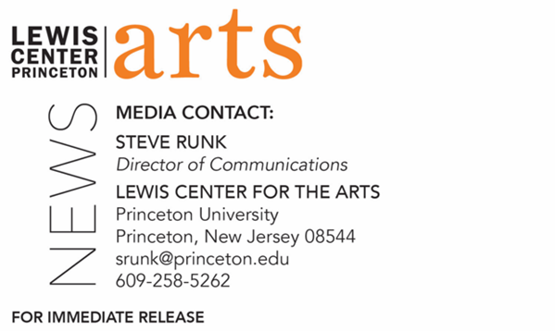

April 7, 2022

Lewis Center for the Arts presents
A concert of original songs by students in the spring course,
“How to Write a Song”
co-taught by Paul Muldoon and Bridget Kearney

Who/What: Princeton students perform a concert of original new songs with music and lyrics written over the past semester as part of the spring Princeton Atelier course “How to Write a Song,” taught by Pulitzer Prize-winning poet Paul Muldoon and Bridget Kearney of Lake Street Dive with a number of guest songwriters and music critics. In the class, small songwriting teams weekly created music and lyrics inspired by such emotionally charged themes as gratitude, revenge, desire, joy, remorse, loneliness, protest, and defiance.
When: Tuesday, April 19, at 4:30 p.m.
Where: Frist Film/Performance Theatre at Frist Campus Center on the Princeton campus
Admission: Free and open to the public. No tickets required, however University students, faculty and staff will need to show their PUID at the door, and public guests will need to attest they are fully vaccinated against COVID-19 to the maximum extent, which now includes a COVID booster shot for all those eligible to receive it. All guests must wear a mask when indoors; musicians may be unmasked while performing. Public guests should enter Frist Campus Center from the entrance facing Washington Road.
Accessibility: Guests in need of access accommodations are asked to contact the Lewis Center at LewisCenter@princeton.edu at least one week prior to the event date.
For more information: https://arts.princeton.edu/events/how-to-write-a-song-concert-of-new-songs-sp-22/

PRINCETON, NJ – Students in Princeton University’s spring course, “How to Write a Song,” offered by the Princeton Atelier at the Lewis Center for the Arts, will present original songs at a concert on Tuesday, April 19, at 4:30 p.m. in the Frist Film/Performance Theatre at Frist Campus Center on the Princeton campus. The students will present selected new songs with music and lyrics written over the past semester. The concert is free and open to the public. No tickets are required; however, University students, faculty and staff will need to show their PUID at the door, and public guests will need to attest they are fully vaccinated against COVID-19 to the maximum extent, which now includes a COVID booster shot for all those eligible to receive it. All guests must wear a mask when indoors; musicians may be unmasked while performing. Public guests should enter Frist Campus Center from the entrance facing Washington Road. Additionally, guests in need of access accommodations are invited to contact the Lewis Center at LewisCenter@princeton.edu at least one week prior to the event date.

“How to Write a Song” is co-taught by Pulitzer Prize-winning poet Paul Muldoon and Bridget Kearney, a founding member of the band Lake Street Drive. Each week the students, all with varying levels of literary and musical backgrounds, split into different groupings of four or five participants and wrote lyrics and composed tunes on an assigned emotional topic, such as gratitude, revenge, desire, joy, remorse, loneliness, protest, and defiance. At each class, the students performed their pieces for Muldoon, Kearney, and their classmates, who then provided critiques. Guest critics and singer/songwriters joined the class to share their experience and to listen to and provide feedback to the student songwriters. Some of the guests this semester included the producer Cautious Clay and Robin Pecknold of Fleet Foxes.

According to Muldoon, “the quality of the work you’ll hear on April 19th is remarkable but will represent only a fraction of what our students have produced. This live concert will be drawing on the best of the eighty or so songs we critiqued over the course of the semester.”

The Princeton Atelier, currently directed by Muldoon, was founded in 1994 by Toni Morrison, Nobel Laureate and Robert F. Goheen Professor in the Humanities, Emeritus, at Princeton University. The Atelier brings professional artists from different disciplines together with Princeton faculty and students to create new work in the context of a semester-long course that culminates in the public presentation of the new work. Participating Atelier artists often select a project they want to explore and experiment within the context of a class with Princeton students before developing it for the professional art world. Previous artists have included the choreographer Jacques d’Amboise, cellist Yo-yo Ma, playwright Branden Jacobs-Jenkins, multimedia artist Laurie Anderson, theater artist Basil Twist, choreographer Monica Bill Barnes, the theater ensemble Elevator Repair Service, percussionist Evelyn Glennie, and the Wakka Wakka puppet theater.

Muldoon is the Howard G.B. Clark ’21 University Professor in the Humanities at Princeton, as well as the founding chair of the Lewis Center for the Arts. As an internationally renowned Irish poet, Muldoon has been described by The Times Literary Supplement as “the most significant English-language poet born since the second World War.” Muldoon won the Pulitzer Prize for his ninth collection of poems, Moy Sand and Gravel (2002). Additionally, he has won the 1994 T.S. Eliot Prize, the 2003 Griffin International Prize for Excellence in Poetry, the 2004 Shakespeare Prize, and the 2006 European Prize for Poetry, among others. His fourteenth volume of poems, Howdie-Skelp, was released in November 2021 by Farrar Straus & Giroux. Muldoon is the editor of the recently released Paul McCartney boxed, two-volume set, The Lyrics: 1956 to the Present, illuminating the stories behind 154 of McCartney’s song lyrics. The book, described as a “self-portrait in 154 songs,” is based on conversations McCartney had with Muldoon, who also penned the introduction, recounting his life and art from all stages of his career. As a musician, Muldoon is a member of the rock band, Rogue Oliphant, that specializes in songs and spoken word pieces

Kearney is a songwriter, multi-instrumentalist, and producer. A founding member of the band Lake Street Dive, she has performed at Radio City Music Hall, The Hollywood Bowl, Red Rocks Amphitheater, and The White House South Lawn, as well as appeared on The Late Show with David Letterman, The Late Show with Stephen Colbert, The Colbert Report, Ellen, and Conan. Her solo debut, "Won't Let You Down," came out in 2017 on Signature Sounds and in 2020 she released a collaborative album written and recorded in Accra, Ghana, called "Still Flying" on Verve Forecast. Kearney holds a Bachelors in Music from the New England Conservatory in Jazz Studies (bass) and Bachelor of Arts from Tufts University in English.

For more information on this event, the Program in Creative Writing, or any of the more than 100 performances, exhibitions, readings, screenings, concerts, and lectures presented each year by the Lewis Center for the Arts, most of them free, visit arts.princeton.edu.

# # #

