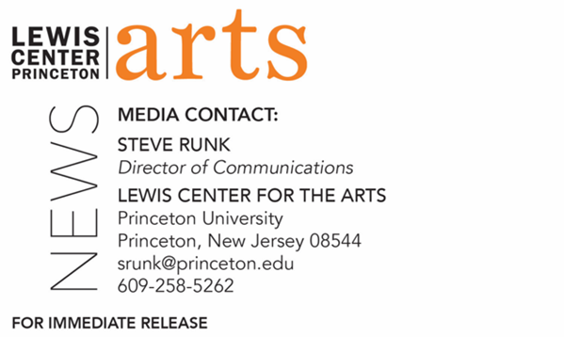
April 14, 2022

Princeton University’s Lewis Center for the Arts presents
Open Masterclass with Stanley Jordan
One of the greatest living jazz musicians of his generation, this member of Princeton’s Class of 1981 works and performs with current Princeton students

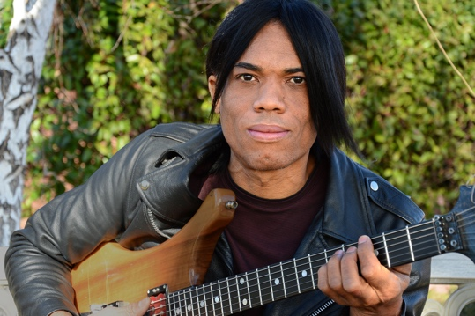
Photo Caption: Stanley Jordan
Photo Credit: Courtesy of Stanley Jordan

Who/What: Princeton welcomes alumnus Stanley Jordan ’81, considered one of the greatest living jazz guitarists and an all-around musical genius, back to campus to share his knowledge and experience with the Princeton community. The public is invited to observe an open masterclass where Jordan will work and perform with current students from the Department of Music’s Jazz Program. Presented by the Lewis Center for the Arts and Department of Music.
When: Thursday, April 21 at 4:30 p.m.
Where: Lee Music Performance & Rehearsal Room at Lewis Arts complex
Admission: Free and open to the public. Tickets are required though University Ticketing at tickets.princeton.edu. All guests are required to be fully vaccinated against COVID-19 to the maximum extent, which now includes a COVID booster shot for all eligible to receive it, and to wear a mask when indoors. Please note that musicians may be unmasked while performing.
Accessibility: Guests in need of access accommodations are asked to contact the Lewis Center at LewisCenter@princeton.edu at least one week prior to the event date.
For more information: https://arts.princeton.edu/events/open-master-class-with-stanley-jordan-81/

PRINCETON, NJ – Princeton University’s Lewis Center for the Arts and the Department of Music present a masterclass with alumnus and legendary jazz guitarist Stanley Jordan, Class of 1981, on Thursday, April 21 at 4:30 p.m. in the Lee Music Performance & Rehearsal Room at the Lewis Arts complex. Jordan is considered by many as one of the greatest living jazz guitarists and an all-around musical genius. He returns to campus to share his knowledge and experience with the Princeton community as he works with and performs with current students from the Department of Music’s Jazz Program. The public is invited to observe. This event is free, however tickets are required though University Ticketing at tickets.princeton.edu. All guests are required to be fully vaccinated against COVID-19 to the maximum extent, which now includes a COVID booster shot for all eligible to receive it, and to wear a mask when indoors. Please note that the musicians may be unmasked while performing. Guests in need of access accommodations are asked to contact the Lewis Center at LewisCenter@princeton.edu at least one week prior to the event date.

Stanley Jordan is a guitarist and composer who has made a major impact on the music scene since his rise to fame in the mid-1980s. He is widely regarded as the foremost expert of the touch, or tapping technique, in which a guitarist uses both hands on the neck of the instrument, allowing him to play simultaneous melodies with a degree of independence previously possible only on the piano. Today this technique is common among guitarists, however, when Jordan started it was virtually unheard of. While at Princeton, Jordan’s technique caught the eye of visiting jazz lecturer Benny Carter, who invited Jordan to join himself and Dizzy Gillespie in a performance at Princeton’s Alexander Hall in 1979. Jordan credits this performance opportunity as one that proved to him that “not only could I hold my own [with world-class musicians]...but it also seemed that my playing inspired them. Music is so much more than just notes, and when I felt that deeper connection, I really began to feel that I had a contribution to make on the world stage.”

In a recent article by Guitar World Magazine, entitled "40 Guitarists Who Changed Our World Since 1980," Jordan was listed among the top five. To date, he has received four Grammy nominations, and his album Magic Touch was Billboard's #1 Jazz Album for 51 weeks. He has done many television appearances through the years including Johnny Carson, Jay Leno, David Letterman, Arsenio Hall, and Jimmy Fallon. He played a cameo role in the movie Blind Date with Bruce Willis and Kim Basinger. Jordan has performed or recorded with a wide variety of artists including Miles Davis, Herbie Hancock, and Sharon Isbin. His guitar work on Kenny Rogers' “Morning Desire" helped make that track the top country song of 1986. During his undergraduate years at Princeton, in addition to honing his own music and techniques, Jordan studied computer music with Paul Lansky and theory and composition with Milton Babbitt. He also did a stint as a DJ at WPRB, Princeton’s radio station. Since his graduation, he has performed in over 70 countries on six continents. He has authored articles for music theory and computer science journals, and he is currently an artist and spokesperson for the American Music Therapy Association.

To learn more about the Lewis Center for the Arts, and the more than 100 public performances, exhibitions, readings, screenings, concerts, lectures, and special events presented by the Lewis Center each year, most of them free, visit arts.princeton.edu.

To learn more about the Department of Music at Princeton, and the many opportunities to engage with public performances, lectures, and masterclasses, visit music.princeton.edu and follow @musicprincetonu on Instagram and Facebook to join this music community online. Learn more about Jazz at Princeton University at http://www.jazzatprinceton.com and follow on Bandsintown.

# # #

