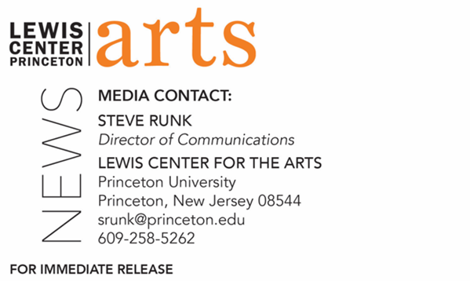
May 13, 2022

Lewis Center for the Arts’ Program in Dance announces the next round of
Caroline Hearst Choreographers-in-Residence
Dianne McIntyre and Cameron McKinney receive support for the development of new work in residence on the Princeton University campus

Photo Caption: Cameron McKinney  Photo Credit: Alice Chacon | 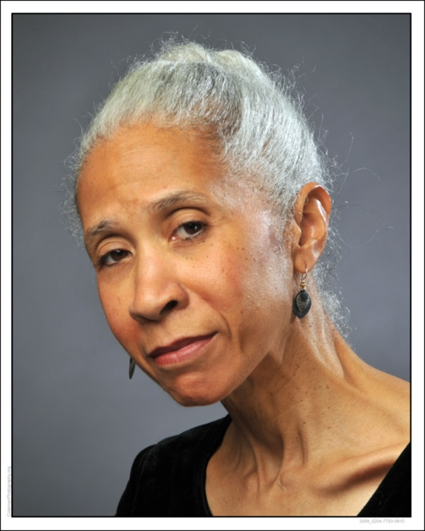  Photo Caption: Dianne McIntyre  Photo Credit: Larry Coleman

PRINCETON, NJ – The Lewis Center for the Arts’ Program in Dance at Princeton University announces two artists as Caroline Hearst Choreographers-in-Residence for the 2021-2022 academic year: Dianne McIntyre and Cameron McKinney. McIntyre and McKinney have spent time this past semester at the Lewis Center engaging with the larger Princeton community and working directly with students while also developing new work with access to the Center’s studios and other resources. They joined earlier named 2021-22 Hearst Choreographers in Residence Kyle Marshall and Larissa Velez-Jackson.

Launched in 2017, the Caroline Hearst Choreographers-in-Residence Program fosters the Program in Dance’s connections with the dance field. It provides selected professional choreographers with resources and a rich environment to develop their work and offers opportunities for students, faculty, and staff to engage with diverse creative practices. The artists share their work and processes with the Princeton community through workshops, conversations, residencies, open rehearsals, and performances. The program is designed to be flexible enough to create meaningful interactions between artists and students, allowing artists to develop engagement activities to suit the interests of the students, and allowing students to create projects that involve the selected artists. Examples of such engagement activities include guest-teaching a class, selecting students to apprentice as choreographic assistants, participating in dinners and conversations with students, and advising student projects.

“The spring Caroline Hearst Choreographers-in-Residence provided extraordinary opportunities for our students to engage with two important artists: acclaimed dance theater pioneer Dianne McIntyre and rising choreographer Cameron McKinney,” said Susan Marshall, Director of the Program in Dance. “Both artists were on campus with their companies, and it was thrilling to watch the experienced professional dancers in open rehearsals and showings and in classes side-by-side with our students. The lively conversations between our students and these groups were revelatory. A highlight of the year was the conversation between Dianne McIntyre and the Dance Program’s own Dyane Harvey-Salaam artfully moderated by Visiting Professor Jasmine Johnson. Dianne and Dyane, whose acclaimed careers have crossed paths repeatedly over their 50-year history-making work in dance, shared personal stories that brought to light the people, places, and issues of dance from the 1970s through to today.”

Dianne McIntyre is regarded as an artistic pioneer with an impressive choreographic career spanning five decades in dance, theater, television and film. The recipient of a 2020 Doris Duke United States Artists Fellowship, the 2019 Dance/U.S.A. Honor, a 2016 Doris Duke Artist Award, as well as a 2007 John S. Guggenheim Fellowship, McIntyre’s individualistic movement style reflects her affinity for cultural histories, personal narratives and the boldness, nuances, discipline and freedom in music and poetic text. Examples of this style are in the dance-driven dramas she creates about real people from interviews she conducts, most notably, I Could Stop on a Dime and Get Ten Cents Change and Open the Door, Virginia! Since 1972, McIntyre has choreographed across genres and disciplines, including for scores of concert dances; four Broadway shows, including August Wilson’s Joe Turner’s Come and Gone; thirty regional theater productions; a London West End musical; two feature films, including Beloved based on Toni Morrison’s novel; three television productions, stage movement for multiple recording artists and five original full-length dance dramas. Her work includes choreography for the recent Lincoln Center Theater production of the opera Intimate Apparel. She has been commissioned by Dance Theatre of Harlem, Alvin Ailey American Dance Theater, Philadanco, Cleo Parker Robinson Dance, GroundWorks Dance Theater, Dancing Wheels, as well as more than 40 university ensembles and major dance festivals. McIntyre’s awards and nominations include three New York Dance Performance “Bessie” Awards, two Audience Development Committee Awards (honoring excellence in African American theater in New York City), a Helen Hayes Award along with four nominations, an Emmy nomination for her choreographer for HBO's award-winning film, Miss Evers’ Boys, the Master of African American Choreography Medal from The Kennedy Center, two honorary Doctor of Fine Arts degrees, and many more. McIntyre is also the co-director of the Hicks Choreography Fellows Program at Jacob’s Pillow. Her mentors include Elaine Gibbs Redmond, Gus Solomons Jr., Louise Roberts and Dr. Richard Davis.

As a Hearst Choreographer-in-Residence, McIntyre participated in a public conversation in April with dance faculty member Dyane Harvey-Salaam on her dance career and their shared experiences beyond the stage, moderated by guest faculty member Jasmine Johnson. McIntyre was also a guest in the advanced spring dance course, “Building Physical Literacies: Practices in Contemporary Dance,” where she shared creative techniques, her process of choreographic creation and improvisational practices. Students noted their appreciation of the depth of wisdom and experience she brought to the classroom.

Additionally, McIntyre continued work on her new piece Speaking in the Same Tongue, during a week-long residency in the Hearst Dance Theater. This piece will be a full-length movement, sound, and language-based exploration of how dance and music “speak” to each other. Princeton students were able to watch McIntyre’s company rehearsals bringing new depths to their understandings of history of the form.

Cameron McKinney, the artistic director of Kizuna Dance, is a New York City-based choreographer and educator. With over 16 years of Japanese language study, he created Kizuna Dance with the mission of using contemporary floorwork to create works that celebrate Japanese culture. He has received fellowships from the United States-Japan Friendship Commission, The School at Jacob’s Pillow, the Alvin Ailey Foundation, and the Asian Cultural Council. Through Kizuna Dance, McKinney has presented work and taught in 18 states, as well as in Mexico, France, the United Kingdom, and Japan at the U.S. Ambassador's Residence. He has choreographed for The Ailey School, Princeton University, Joffrey Ballet School, Let’s Dance International Frontiers Festival (U.K.), Slippery Rock University, The Dance Gallery Festival, Old Dominion University, and Bates College, among others. Additionally, McKinney has served as an adjunct and visiting lecturer at Princeton University, Bard College, and Queensborough Community College. He has been a faculty member at Gibney Dance since 2016 and has taught for festivals nationally and internationally. McKinney is currently building Nagare Technique, a training module that blends street dance styles and contemporary floorwork. In 2021, he launched the inaugural Open Intensive, a week of day-long intensives made entirely free for all participants, featuring high-quality dance education provided by the company artists of Kizuna Dance.

As a Hearst Choreographer-in-Residence, McKinney was joined by six members of his company, Kizuna dance, to lead an intensive series of classes in his technique, Nagare, that incorporates his research into Butoh practices, contemporary floorwork, and street dance styles. McKinney’s company developed a new work and shared excerpts during a showing with students. McKinney introduced new definitions and approaches to contemporary dance that allowed students to center their personal histories and eclectic movement backgrounds in their physical research.

Hearst Choreographers-in-Residence are chosen yearly through a nomination process and include choreographers at various stages of their careers exploring a wide range of aesthetics, including those who may not otherwise fit easily into the Dance Program’s curriculum. The Hearst Choreographers-in-Residence program is supported through a gift from Margaret C. and William R. Hearst.

For more information on the Program in Dance, future events related to the choreographers-in-residence program, and the more than 100 other performances, exhibitions, readings, screenings, concerts and lectures offered each year by the Lewis Center for the Arts, most of them free, visit arts.princeton.edu.
###

