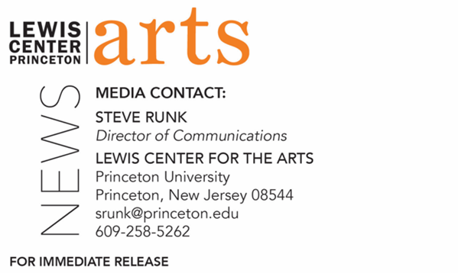

May 4, 2022

The Lewis Center for the Arts presents
MWEDZI: An ancestral song cycle
Original music for mbira, voice, and piano by 2021-22 Hodder Fellow and alumna Tanyaradzwa Tawengwa ’14 followed by a talk with artistic collaborators

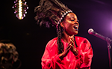
Photo Caption: 2021-22 Princeton Hodder Fellow and alumna Tanyaradzwa Tawengwa, Class of 2014
Photo Credit: Courtesy of Tanyaradzwa Tawengwa

Who/What: 2021-22 Hodder Fellow and Princeton alumna Tanyaradzwa Tawengwa, Class of 2014, performs original music for mbira, voice, and piano inspired by her ancestral rite of passage into womanhood, followed by a moderated conversation with Marcus Zvinavashe, Nyasha Jeche, and Ulenni Okandlovu from CaliGraph and Skeyi and Strobo, two Zimbabwe-based multidisciplinary art collectives, who worked on imagery for her forthcoming album, MWEDZI.
When: Wednesday, May 11 at 7:30 p.m.
Where: Forum at the Lewis Arts complex
Admission: Free and open to the public. Tickets are required though University Ticketing at tickets.princeton.edu. All guests are required to be fully vaccinated against COVID-19 to the maximum extent, which now includes a COVID booster shot for all eligible to receive it, and to wear a mask when indoors. Please note that performers and speakers may be unmasked while presenting.
Accessibility: Guests in need of access accommodations are asked to contact the Lewis Center at LewisCenter@princeton.edu at least one week prior to the event date.
For more information: https://arts.princeton.edu/events/concert-and-conversation-with-hodder-fellow-tanyaradzwa-tawengwa/

PRINCETON, NJ – Princeton University’s Lewis Center for the Arts presents a performance by Princeton alumna and 2021-22 Hodder Fellow Tanyaradzwa Tawengwa of music from her forthcoming album, MWEDZI: An ancestral song cycle, featuring her original music for mbira, voice, and piano inspired by her ancestral rite of passage into womanhood. The performance will be followed by a moderated conversation with Marcus Zvinavashe, Nyasha Jeche, and Ulenni Okandlovu from CaliGraph and Skeyi and Strobo, two Zimbabwe-based multidisciplinary art collectives who worked with Tawengwa on the imagery for her album. This event will be on Wednesday, May 11 at 7:30 p.m. in the Forum of the Lewis Arts complex and is free and open to the public. Tickets are required though University Ticketing at tickets.princeton.edu. All guests are required to be fully vaccinated against COVID-19 to the maximum extent, which now includes a COVID booster shot for all eligible to receive it, and to wear a mask when indoors. Please note that performers and speakers may be unmasked while presenting. Guests in need of access accommodations are asked to contact the Lewis Center at LewisCenter@princeton.edu at least one week prior to the event date.

Tanyaradzwa Tawengwa is a Zimbabwean gwenyambira (mbira player), composer, singer, scholar, and healer. Her craft is grounded in the Chivanhu ancestral canon taught to her by the generations of Svikiro (spirit mediums) and N’anga (healers) in her bloodline. She notes her work calls for a reintegrative practice that heals the spiritual, emotional, physical, and intellectual disembodiment caused by the 600-year colonial war waged against her people. Tawengwa earned her B.A. in Music Composition at Princeton University (cum laude) and her M.M. and her doctorate in Voice Performance from the University of Kentucky. During her year as a Hodder Fellow, Tawengwa has been composing Mudzimu Dzoka, a biomythographical, multi-disciplinary performance piece detailing her re-embodiment of Zimbabwean ancestral practices as a panacea for colonial disembodiment. She will also produce an auto-theoretical article in a comic book format called Cultural Vampires: White Exploitation of Zimbabwean Mbira Music.
As a sophomore at Princeton, Tawengwa received a prestigious Alex Adam Award from the Lewis Center, which supported a summer at the Ethnomusicology Department of the Zimbabwe College of Music, where she built on her studies by concentrating on indigenous musical styles to complement her training in Western music. At Princeton she founded the a cappella group Umqombothi and was a member of Earthtones, an African dance ensemble.

Marcus Zvinavashe and Nyasha Jeche are the founders of CaliGraph, a mural-creation company whose goal is to use shared spaces to tell stories of history, culture, and traditions. When speaking to GQ South Africa, Zvinavashe said of the group’s art, “For us, one of our aims is to effectively communicate with people during and after the mural is put up...Our goal is to encourage people and the community to have conversations, for kids to start asking questions, and to encourage understanding.” Though the group has created over a hundred murals in Zimbabwe and Zambia touching on many different themes including #GirlPower, CaliGraph rose to fame during the COVID 19 pandemic as it took to public spaces to paint murals featuring local celebrities encouraging people to follow precautions such as wearing a mask and social distancing. Zvinavashe and Jeche met while attending Chinhoyi University in Zimbabwe, and after graduating they created CaliGraph as a way to make their own artistic opportunities. CaliGraph has collaborated with brands such as British Council, GOAL Zimbabwe, the British Embassy, Paper Bag Africa, and the National Gallery in Bulawayo, among others.

Ulenni Okandlovu is a musician, digital storyteller, and the creative director of Skeyi and Strobo, a multifaceted studio dedicated to archiving, showcasing, and telling Zimbabwe’s untold contemporary stories through film, fashion, and photography. Skeyi and Strobo works closely with CaliGraph to document and film the process of creating each mural. Additionally, Skeyi and Strobo hosts an annual Fabrik Party in downtown Harare, Zimbabwe, which brings together a group of young innovators, tastemakers, stylists, and forward thinkers to discuss, network, and create. As a musician, Okandlovu is the co-founder and lead vocalist of the experimental music duo BantuSpaceships. He also released a solo album in 2021, The Last King of Matabeleland.

To learn more about the Lewis Center for the Arts, and the more than 100 public performances, exhibitions, readings, screenings, concerts, lectures, and special events presented by the Lewis Center each year, most of them free, visit arts.princeton.edu.
# # #

