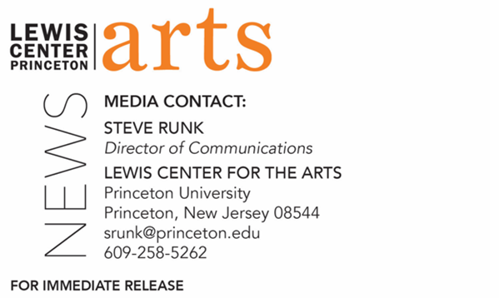
June 21, 2022

Professor Judith Hamera, Award-winning Dance and Performance Studies Scholar, named next Chair of the Lewis Center for the Arts

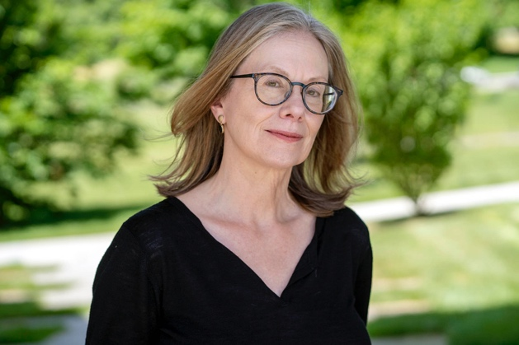
Photo caption: Professor Judith Hamera, award-winning dance and performance studies scholar, is new chair of Princeton University’s Lewis Center for the Arts.
Photo credit: Jonathan Sweeney

PRINCETON, NJ – Princeton University has named Professor of Dance Judith Hamera, an award-winning dance and performance studies scholar, as next chair of the University’s Lewis Center for the Arts. Hamera takes over from Michael Cadden, who served as interim chair for the 2021-22 academic year. Hamera will begin her new duties on July 1, 2022.

“I am so happy that Judith Hamera has agreed to serve as the next chair of the Lewis Center!” said Cadden. “Her work testifies to a lifelong interest in seeing connections among the arts and making connections among people living embodied lives in the worlds of academia and artistic practice—and the many other worlds we each inhabit. The Lewis Center dances on the bridges between those worlds and, as a scholar and teacher, Professor Hamera has surveyed many of them with ingenious results. Her eloquence, vision, and work ethic will serve us well—as will her commitment to an engagement with the entirety of our University, local, national, and international communities.”

Hamera has been a faculty member in the Lewis Center for the Arts’ Program in Dance since 2014 and holds a faculty appointment in the University’s Effron Center for the Study of America, as well as affiliations with the Programs in Gender and Sexuality Studies and Urban Studies.

Hamera’s most recent book, Unfinished Business: Michael Jackson, Detroit, and the Figural Economy of American Deindustrialization (Oxford University Press, 2017) places economic theory in conversation with performance studies to examine representations of race in American deindustrialization. It received the 2018 Outstanding Book Award from the Association for Theatre in Higher Education, the 2017-2018 Biennial Sally Banes Publication Prize from the American Society for Theatre Research, and the 2020 Oscar G. Brockett Book Prize for Dance Research awarded to the best dance studies book of the past three years by the Dance Studies Association. Her 2019 article, “Rehearsal Problems: Gus Giordano, The Rehearsal, and the Critical Utility of Forgotten Dance Triumphs,” received the Gertrude Lippincott Award for Best English Language Dance Studies Article, also from the Dance Studies Association.

Hamera’s other books include Parlor Ponds: The Cultural Lives of the American Home Aquarium, 1870-1970 (University of Michigan Press, 2012), which posits theatricality and the theater as crucial to both the emerging popularity of the hobby and to its social work; Dancing Communities: Performance, Difference and Connection in the Global City (Studies in International Performance: Palgrave Macmillan, 2007; 2011), which received the Book of the Year award from the National Communication Association’s Ethnography Division; the Cambridge Companion to American Travel Writing (Cambridge University Press, 2009) co-edited with Alfred Bendixen; Opening Acts: Performance In/As Communication and Cultural Studies (Sage, 2006); and the Handbook of Performance Studies (Sage, 2006), co-edited with D. Soyini Madison (2006).

Her essays have appeared in Communication and Critical/Cultural Studies, Cultural Studies, Cultural Studies—Critical Methodologies, Dance Research Journal, Modern Drama, PMLA, Qualitative Inquiry, TDR: The Drama Review, Text and Performance Quarterly, Theatre Journal, Theatre Survey, Theatre Topics, Women and Language, and Women’s Studies.

Hamera is the recipient of the National Communication Association’s Lilla Heston Award for Outstanding Scholarship in Performance Studies and has served as editor of Text and Performance Quarterly, the performance studies journal of the National Communication Association.

Hamera received her B.A. in Mass Communications from Wayne State University and her M.A. and Ph.D. in Interpretation and Performance Studies, respectively, from Northwestern University.

“I am honored to serve the Lewis Center for the Arts as its next chair, grateful to my predecessors who built this dynamic and vital unit and energized by the work of my brilliant colleagues and our students,” said Hamera. “The arts press us to rigorously investigate our most foundational personal and societal questions and imagine new futures. I look forward to advancing the LCA’s commitment to this necessary and urgent work, and to welcoming even more members of the Princeton community to join us in our courses, events, and efforts.”

For the 2021-22 academic year, Hamera was an Old Dominion Research Professor with Princeton’s Humanities Council, conducting research for her next project, “Los Angeles Live Art and Critical Pluralist Imaginaries, 1989 – 2000,” which examines the ways interrelationships between experimental live art; critical theories of aesthetics, gender, sexuality, race, and identity from the humanities and humanistic social sciences; and the alternative arts press shaped public responses to crises of civic pluralism in Los Angeles between 1989 and 2000.

University Lecturer Cadden stepped in as chair after having previously served in this position from 2011-2019, when he succeeded the founding chair Paul Muldoon. In his first tenure as chair, Cadden saw the Lewis Center through a pivotal time in the development of the Center including the final design, construction, and opening of the 145,000 square foot Lewis Arts complex in fall 2017, celebrated by a four-day festival of the arts that attracted over 3,500 visitors. Additionally, under his leadership, the Center experienced significant growth and diversification of its course offerings, faculty, course enrollments, and presentation of public events. Cadden launched the Princeton Arts Fellowship program, the Roger S. Berlind Playwright-in-Residence program, the new Program in Music Theater certificate, and the Hearst Choreographer-in-Residence program, among other new initiatives. Cadden will continue to teach in the Program in Theater after he steps down as chair.

The Lewis Center offers courses through Princeton University’s programs in creative writing, dance, theater, music theater and the visual arts, as well as through the interdisciplinary Princeton Atelier founded by Professor Emerita Toni Morrison. Nearly 2,000 Princeton undergraduates are enrolled in 200 Lewis Center for the Arts courses each year, more than one-fourth the undergraduate student body. The Center also presents more than 120 public performances, exhibitions, readings, film screenings, concerts, and lectures each year, most of them free.

To learn more about the Lewis Center for the Arts visit arts.princeton.edu.

###

