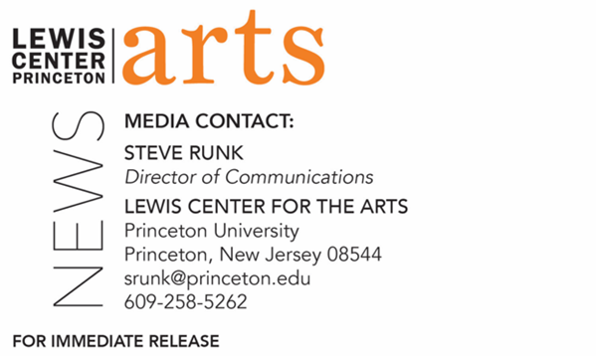

June 8, 2022

Yiyun Li Named Director of Princeton University’s
Program in Creative Writing

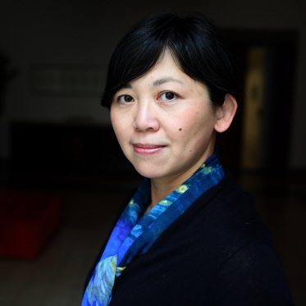
Photo Caption: Award-winning writer Yiyun Li, new director of Princeton’s Program in Creative Writing
Photo Credit: Photo by ©Basso CANNARSA / Opale

PRINCETON, NJ – Princeton University’s Lewis Center for the Arts has named award-winning writer Yiyun Li as the new director of the University’s Program in Creative Writing. Li, a Professor of Creative Writing on the Princeton faculty since 2017, succeeds Pulitzer Prize-winning author Jhumpa Lahiri, who has led the program since 2019. Li begins her tenure as director on July 1.

“I am delighted that Yiyun Li has agreed to accept the role of Director of the Lewis Center's Program in Creative Writing,” said Michael Cadden, interim chair of the Center. “Writers are properly protective of their ‘alone’ time, but Yiyun's sense of responsibility, collegiality, and devotion to our students have brought her to this decision. I first wrote her a fan note over fifteen years ago, little suspecting that one day she would be a colleague -- and one of the key figures in Princeton's ever-evolving arts landscape. We are so fortunate to have her at the University -- and even more fortunate that she has accepted this leadership role.”

Yiyun Li is the author of ten books, including The Book of Goose, Where Reasons End, Dear Friend, from My Life I Write to You in Your Life, and Tolstoy Together, 85 Days of War and Peace with Yiyun Li. Her work has been translated into more than 20 languages. Li’s honors and awards include a MacArthur Foundation Fellowship, a Guggenheim Foundation Fellowship, a Windham Campbell Prize, the 2021 Literature Award from the American Academy of Arts and Letters, the Benjamin H. Dank Award from the American Academy of Arts and Letters, the Sunday Times EFG Short Story Award, the PEN/Jean Stein Award, the PEN/Malamud Award, the PEN/Hemingway Award, The Guardian First Book Award, the Asian American Literary Award for fiction, and others. She is a member of the American Academy of Arts and Sciences. A Thousand Years of Good Prayers, an independent film directed by Wayne Wang and adapted by Li from her short story, was the winner of a Golden Shell for Best Film at the 55th San Sebastian International Film Festival.

Born in Beijing, China, Li began writing in English in her twenties when she came to the United States to earn an M.S. in immunology from the University of Iowa. She then returned to the university five years later and earned an M.F.A. in creative non-fiction from the Non-fiction Writing Program and the famed Writers’ Workshop at the University of Iowa.

“Princeton’s creative writing program has been an inspiring community, cultivated by generations of writers and Princeton students,” said Li. “I am delighted to be the next director and continue the tradition of supporting and celebrating the literary arts.”

Princeton’s Program in Creative Writing began in 1939, when Dean Christian Gauss approached the Carnegie Foundation to help the University focus on the cultivation of writers and other artists. He appointed poet and critic Allen Tate as the first Resident Fellow in Creative Writing. Since then, world-renowned writers have served as faculty and visiting guest writers including Simon Armitage, John Berryman, Elizabeth Bowen, Jeffrey Eugenides, Robert Fitzgerald, Thomas Gunn, Edmund Keeley, David E. Kelley, Chang-rae Lee, John McPhee, Lorrie Moore, Neel Mukherjee, Joyce Carol Oates, Philip Roth, Claudia Rankine, Erika Sanchez, Delmore Schwartz, Edmund White, Kevin Young, Tracy K. Smith, and Nobel laureates Toni Morrison and Mario Vargas Llosa.

Currently the faculty also includes award-winning writers Michael Dickman, Aleksandar Hemon, A.M. Homes, Christina Lazaridi, Paul Muldoon, Kirstin Valdez Quade, Susan Wheeler, and a number of distinguished lecturers and visiting professors.

It is with these internationally known writers that over 300 Princeton undergraduates take courses in poetry, fiction, screenwriting, and literary translation each semester, a number that continues to grow. Small workshop courses, averaging eight to ten students, provide intensive feedback and instruction for both beginning and advanced writers. Through the Program, students can earn a certificate in creative writing in addition to their degree in a major. Each year, these 20 to 30 seniors work individually with a member of the faculty on a creative writing thesis, such as a novel, screenplay, or a collection of short stories, poems, or translations.

Some of these senior thesis projects become the first published work by graduates of the program, as was the case for writers Jonathan Ames ’87 and Jonathan Safran Foer ’99. Other graduates from the program include Catherine Barnett ’82, Jane Hirshfield ’73, Boris Fishman ’01, Kristiana Kahakauwila ’03, Galway Kinnell ’48, Walter Kirn ’83, William Meredith ’40, W. S. Merwin ’48, Emily Moore ’99, Jodi Picoult ’87, Julie Sarkissian ’05, Akhil Sharma ’92, Whitney Terrell ’91, and Monica Youn ’93.

Lahiri is leaving Princeton to join the faculty at her undergraduate alma mater Barnard College as the Millicent C. McIntosh Professor of English and Director of Creative Writing.

To learn more about the Lewis Center for the Arts and the Program in Creative Writing visit arts.princeton.edu.

###

