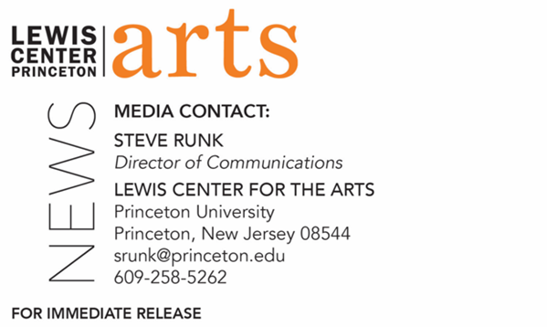

August 29, 2022

Fund for Irish Studies at Princeton University presents
The News from Dublin: A Reading by Colm Tóibín
Acclaimed, award-winning writer opens the 2022-2023 series

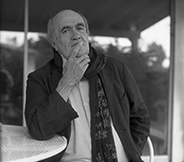
Photo Caption: Acclaimed, award-winning writer Colm Tóibín
Photo Credit: Reynaldo Revera

Who/What: In a special event opening the 2022-23 Fund for Irish Studies Series, the acclaimed novelist, playwright and poet Colm Tóibín will read, for the first time, his new short story, “The News from Dublin,” and several of his recent poems. Colm Tóibín is one of the most widely admired of contemporary novelists. Born in Enniscorthy, Ireland, in 1955, he has won the LA Times Novel of the Year for The Master, the Costa Novel of the Year for Brooklyn and the Hawthornden Prize for Nora Webster. His short story collections include Mothers and Sons, winner of the Edge Hill Prize. His most recent novel is The Magician. He has recently published his first collection of poems, Vinegar Hill, described by The New York Times as “A meditative probe into the language of ordinary days.” Introduced by Fintan O’Toole.
When: Friday, September 9, at 4:30 p.m.
Where: James Stewart Film Theater at 185 Nassau St.
Admission: Free and open to the public; no tickets required. All guests must either be fully vaccinated, or have recently tested negative and be prepared to show proof if asked, or wear a face covering when indoors and around others.

Accessibility: Guests in need of access accommodations are asked to contact the Lewis Center at LewisCenter@princeton.edu at least one week prior to the event date.
For more information: https://arts.princeton.edu/events/fund-for-irish-studies-reading-by-colm-toibin/

PRINCETON, NJ – Princeton University’s Fund for Irish Studies opens its 2022-23 series with a special event, The News from Dublin: A Reading by Colm Tóibín, featuring the acclaimed, award-winning novelist, playwright, and poet. The reading will take place on Friday, September 9, at 4:30 p.m. at the James Stewart Film Theater at 185 Nassau Street. Princeton’s Visiting Leonard L. Milberg '53 Professor in Irish Letters and Chair of the Fund for Irish Studies Fintan O’Toole will provide a welcome and introduction. The event is free and open to the public; no tickets are required. Guests in need of access accommodations are asked to contact the Lewis Center at LewisCenter@princeton.edu at least one week prior to the event date.

Colm Tóibín is the author of ten novels, including The Magician, winner of the Rathbones Folio Prize; The Master, winner of the Los Angeles Times Book Prize; Brooklyn, winner of the Costa Book Award and adapted as the Oscar-nominated film starring Saoirse Ronan; The Testament of Mary; Nora Webster, winner of the Hawthornden Prize; The South, winner of the Irish Times/Aer Lingus First Fiction Award; as well as two story collections, Mothers and Sons, winner of the Edge Hill Prize and The Empty Family; and several books of criticism. He is a regular contributor to the The New York Review of Books and a contributing editor at the London Review of Books. His work as a journalist and travel writer includes The Trial of the Generals, Bad Blood: A Walk Along the Irish Border, and The Sign of the Cross: Travels in Catholic Europe. Also a playwright, the adaptation of his novella The Testament of Mary as a play of the same title opened on Broadway in 2013 with Fiona Shaw and was nominated for a Tony Award for Best Play, as well as being released as an audiobook with Meryl Streep. Published earlier this year, his first collection of poems, Vinegar Hill, was described by The New York Times as “A meditative probe into the language of ordinary days.” Tóibín’s work has been translated into more than 30 languages, and three books on his work have been published. He has twice been visiting Stein writer at Stanford University and has also been a visiting writer at the University of Texas at Austin. He taught at Princeton from 2009 to 2011 and was a professor of creative writing at the University of Manchester in 2011. He is currently Mellon Professor in the Department of English and Comparative Literature at Columbia University and Chancellor of Liverpool University. He has been named as the Laureate for Irish Fiction for 2022–2024 by the Arts Council of Ireland. Three times shortlisted for the Booker Prize, Tóibín lives in Dublin and New York.

O’Toole’s books on politics include the recent best sellers We Don't Know Ourselves: A Personal History of Modern Ireland and Heroic Failure: Brexit and the Politics of Pain. His books on theater include works on William Shakespeare, Richard Brinsley Sheridan, and Thomas Murphy. He regularly contributes to The New York Review of Books, The New Yorker, Granta, The Guardian, The Observer, and other international publications. In 2011, The Observer named O’Toole one of “Britain’s top 300 intellectuals.” He has received the A.T. Cross Award for Supreme Contribution to Irish Journalism, the Millennium Social Inclusion Award, Journalist of the Year in 2010, the Orwell Prize, and the European Press Prize. O’Toole’s History of Ireland in 100 Objects, which covers 100 highly charged artifacts from the last 10,000 years, is currently the basis for Ireland’s postage stamps. His most recent book is Judging Shaw: The Radicalism of GBS, published by the Royal Irish Academy. He has recently been appointed official biographer of Nobel Prize-winning poet Seamus Heaney.

The Fund for Irish Studies is chaired this year by O’Toole and affords all Princeton students, and the community at large, a wider and deeper sense of the languages, literatures, drama, visual arts, history, and economics not only of Ireland but of “Ireland in the world.” The lecture series is co-produced by the Lewis Center for the Arts.

Information about the Fund for Irish Studies lecture series events can be found at fis.princeton.edu. Other fall events in the 2022-2023 series will include Irish film and television director Lenny Abrahamson on October 14, a lecture by scholar Helen Phelan entitled “’Low the sun; short its course’: Tracing the Celtic ritual cycle through music, manuscript, and performance” on October 28, and writer and documentary-maker Manchán Magan on November 11. Additional events for the spring are being planned.

The Fund for Irish Studies is generously sponsored by the Durkin Family Trust and the James J. Kerrigan Jr. ’45 and Margaret M. Kerrigan Fund for Irish Studies.

To learn more about the more than 100 public performances, exhibitions, readings, screenings, concerts, lectures, and special events, most of them free, presented each year by the Lewis Center for the Arts, visit arts.princeton.edu.

# # #

