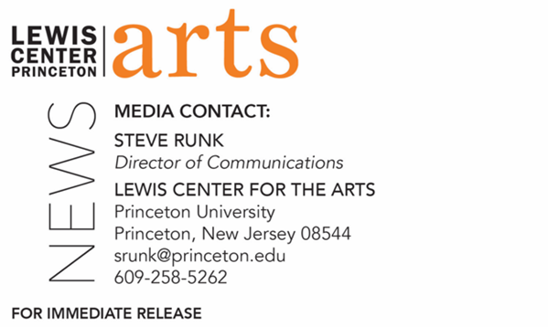

September 13, 2022

Lewis Center for the Arts’ Program in Theater presents
Ask Your Questions with Daniel Alexander Jones
Event is culmination of a weeklong residency by Jones, an award-winning, interdisciplinary artist and Belknap Short-Term Visiting Fellow in Princeton’s Humanities Council, along with Deborah Paredez of Columbia University

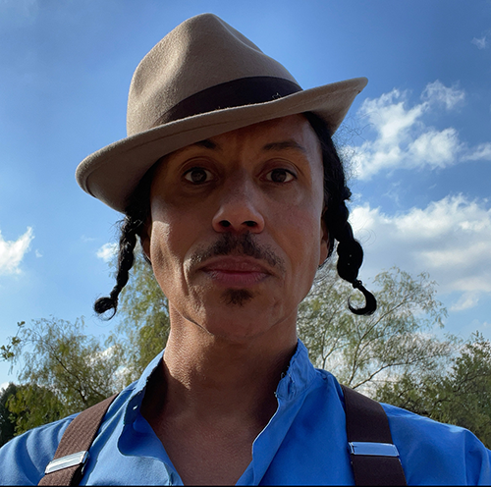
Photo caption: Award-winning, interdisciplinary artist and Belknap Short-Term Visiting Fellow in Princeton’s Humanities Council Daniel Alexander Jones
Photo credit: Courtesy of Daniel Alexander Jones

Who/What: Daniel Alexander Jones, an award-winning, interdisciplinary artist and Belknap Short-Term Visiting Fellow in Princeton’s Humanities Council, culminates a week-long residency with members of the University community to construct an altar with a public conversation and celebration. Centered around the prompt “Ask Your Questions,” the conversations, offerings, building and activation of the altar is rooted in the cultivation of intentional space for inquiry, deep listening, and consideration of traditional practices of presence, particularly those rooted in Black Queer interiorities. The September 23 conversation includes Dr. Deborah Paredez of Columbia University and features both artists reading from their work and discussing not only their own questions, but questions born of the week’s activities, followed by time for celebration.
When: September 23 at 4:30 p.m.
Where: CoLab at Lewis Arts complex on the Princeton University campus
Tickets: Free and open to the public. All guests must either be fully vaccinated, or have recently tested negative and be prepared to show proof if asked, or wear a face covering when indoors and around others.
Accessibility: The Lewis Arts complex is an accessible venue. Guests in need of access accommodations are invited to contact the Lewis Center at least one week in advance at LewisCenter@princeton.edu
For more information: https://arts.princeton.edu/events/ask-your-questions-a-residency-with-daniel-alexander-jones/2022-09-23/

PRINCETON, NJ – The Lewis Center for the Arts’ Program in Theater at Princeton University invites the community to Ask Your Questions, the culminating event in a residency by award-winning, interdisciplinary artist Daniel Alexander Jones, on September 23 at 4:30 p.m. in the CoLab at the Lewis Arts complex on the Princeton campus. Jones is a Belknap Short-Term Visiting Fellow in Princeton’s Humanities Council. This event is free and open to the public; no tickets are required.

Jones will spend September 19 through 23 working with University students, faculty and staff on collectively building an altar centered around the prompt, “Ask Your Questions.” The conversations, offerings, building and activation of the altar is rooted in the cultivation of intentional space for inquiry, deep listening, and consideration of traditional practices of presence, particularly those rooted in Black Queer interiorities. The culminating event will also feature Dr. Deborah Paredez of Columbia University with both artists reading from their work and discussing not only their own questions, but questions born of the week’s activities, followed by time for celebration.

Daniel Alexander Jones has been recognized as a groundbreaking and visionary artist through such awards as a Guggenheim Fellowship, a Doris Duke Artist grant, a U.S.A. Artist Fellowship and a Creative Capital grant, as well as commissions from McCarter Theatre and The Public Theater. Over 25 years into his distinctive interdisciplinary practice, Jones has woven performance art, theater, music, writing, and teaching into an eclectic body of work. His pieces include www.aten.life, which premiered as a digital music, video and interactive site through CalArts Center for New Performance and New York Live Arts; Black Light at The Public Theater; Duat at Soho Rep; and Phoenix Fabrik at Pillsbury House Theatre. 53rd State Press recently published Love Like Light, a collection of seven works from across Jones’s career, featuring introductory essays from a range of collaborators and colleagues; as well as the book Particle & Wave, a conversation with Dr. Alexis Pauline Gumbs that contextualizes Jones’s practice. He received the 2021 PEN America/Laura Pels Foundation Award in Theatre and was praised for “perfecting a dramaturgy all his own based in the traditions of Africana studies, performance studies, queer theory, and mysticism, challenging established traditions while creating space for audiences to ponder what theater is and who it is for." Jones has released six albums as his alter-ego Jomama Jones. He will release his first album under his own name later this year. He has taught at universities for 20 years, most recently as a full professor at Fordham University. Jones lives in Los Angeles, where he is a producing artist for the Center for New Performance at CalArts and is in residence with UCLA’s Center for the Art of Performance.

Deborah Paredez is a poet and cultural critic. She is the author of the poetry volumes This Side of Skin (Wings Press 2002) and Year of the Dog (BOA Editions 2020), and the critical study Selenidad: Selena, Latinos, and the Performance of Memory (Duke UP, 2009). Her poetry and essays have appeared in Poetry magazine, The New York Times, Los Angeles Review of Books, Boston Review, Poet Lore, and elsewhere. She is the cofounder and for a decade served as codirector (2009-2019) of CantoMundo, a national organization for Latinx poets. She lives in New York City, where she teaches creative writing and ethnic studies at Columbia University.

Through the Humanities Council’s Belknap Short-Term Visiting Fellows program, selected scholars, artists, writers, and practitioners engage in intensive three- to five-day visits that may include lecture and participation in classes, colloquia, and informal discussions. Belknap Long-Term and Short-Term Visitors are made possible with support from the Belknap Visitors in the Humanities Fund, the Class of 1932 Visiting Lectureship Fund, the David A. Gardner ’69 Magic Project, the Eberhard L. Faber Class of 1915 Memorial Lecture Fund, the Edward T. Cone ’39 Humanities Fund, the Old Dominion Fellowship Fund, the Virginia and Richard Stewart Memorial Fund, and the Whitney J. Oates Fund for Scholarship in the Humanities.

All guests must either be fully vaccinated, or have recently tested negative (via PCR within 72 hours or via rapid antigen test within 8 hours of the scheduled visit) and be prepared to show proof if asked, or wear a face covering when indoors and around others.

The Lewis Arts complex is an accessible venue. Guests in need of access accommodations are invited to contact the Lewis Center at least one week in advance at LewisCenter@princeton.edu

To learn more about this event, the Program in Theater, and the more than 100 performances, exhibitions, readings, screenings, concerts, and lectures presented each year at the Lewis Center, most of them free, visit arts.princeton.edu.
# # #

