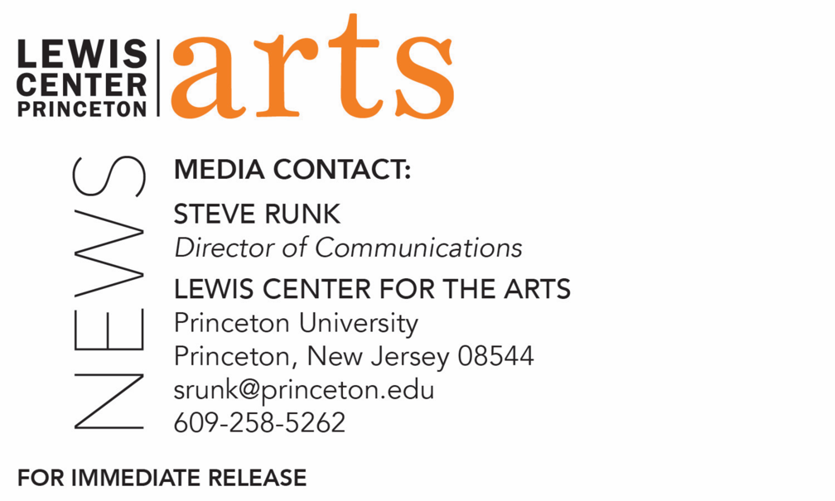

September 23, 2022

Lewis Center for the Arts’ Program in Creative Writing presents a reading by
Sylvie Baumgartel and Amy Tan
Acclaimed writers open the 2022-23 Althea Ward Clark W’21 Reading Series
at Princeton

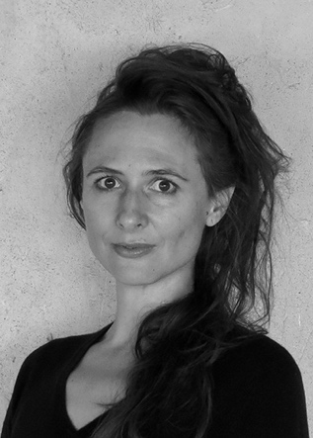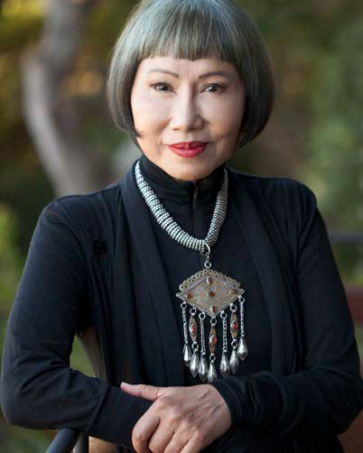

Photo caption 1: Sylvie Baumgartel
Photo credit 1: Barbara Hanson
Photo caption 2: Amy Tan
Photo credit 2: Julian Johnson / Stephen Barclay Agency

What/Who: The 2022-23 Althea Ward Clark W’21 Reading Series opens with a reading by poet Sylvie Baumgartel (Pink) and bestselling novelist Amy Tan (The Joy Luck Club), presented by the Lewis Center for the Arts’ Program in Creative Writing at Princeton University
When: October 4 at 7:30 p.m.
Where: James Stewart Film Theater at 185 Nassau Street on the Princeton University campus
Admission: Free and open to the public; no tickets are required. All guests must either be fully vaccinated, or have recently tested negative and be prepared to show proof if asked, or wear a face covering when indoors and around others.
Accessibility: The Film Theater is an accessible venue. Guests in need of access accommodations are invited to contact the Lewis Center at LewisCenter@princeton.edu at least one week prior to the event date.
For more information:
https://arts.princeton.edu/events/reading-by-sylvie-baumgartel-amy-tan/

(Princeton, N.J.) The Althea Ward Clark W’21 Reading Series, presented by the Lewis Center for the Arts’ Program in Creative Writing at Princeton University, opens the 2022-23 season with a reading by poet Sylvie Baumgartel and bestselling novelist Amy Tan. The reading begins at 7:30 p.m. in the James Stewart Film Theater at 185 Nassau Street on the Princeton University campus. The reading is free and open to the public; no tickets are required, however seating is limited and audiences are encouraged to arrive early to secure a seat. Doors will open at 7:00 p.m. The Film Theater is an accessible venue. Guests in need of access accommodations are invited to contact the Lewis Center at LewisCenter@princeton.edu at least one week prior to the event date.

Sylvie Baumgartel has published two books of poetry: Song of Songs (2019) and Pink (2021). Her poems have appeared in The New Yorker, The Financial Times, The Paris Review, The Virginia Quarterly Review, The Nation, Harvard Review, Subtropics, the PEN Poetry series and elsewhere. Reviewing her most recent collection, Publisher's Weekly notes that "One of [Baumgartel's] strengths is her ability to approach grisly subjects without hesitation or theatrical indulgence...Baumgartel offers a kinetic and transgressive testament to an age of violence, strangeness, and bewilderment." She lives in Santa Fe, New Mexico.
Amy Tan’s novels include The Joy Luck Club, The Kitchen God's Wife, The Hundred Secret Senses, The Bonesetter's Daughter, Saving Fish from Drowning, and The Valley of Amazement, all New York Times bestsellers. She is also the author of two children's books and numerous articles for magazines including The New Yorker, Harper’s Bazaar, and National Geographic, as well as the short story, “Rules for Virgins,” published as an audiobook. Her work has been translated into 35 languages, and her essays and stories are found in hundreds of anthologies and textbooks. Tan has written a memoir, The Opposite of Fate, and a book about writing titled Where the Past Begins: A Writer’s Memoir. She was also a co-producer and co-screenwriter of the film version of The Joy Luck Club and the librettist for the opera The Bonesetter's Daughter. Tan is winner of the National Book Award, the National Book Critics Circle Award, the International Orange Prize, the Commonwealth Gold Award, and the F. Scott Fitzgerald Award for Achievement in American Literature. She is also the recipient of the 2021 Carl Sandburg Literary Award from Chicago Public Library and the Chicago Public Library Foundation. In March 2022 she was voted into the American Academy of Arts and Letters. Her next book, The Backyard Bird Chronicles, is forthcoming in October 2023.
The Lewis Center’s Program in Creative Writing annually presents the Althea Ward Clark W’21 Reading Series, which provides an opportunity for students, as well as all in the greater Princeton region, to hear and meet the best contemporary writers. The series is organized by Lecturer in Creative Writing and award-winning poet Michael Dickman. All readings are at 7:30 p.m. in the James Stewart Film Theater and are free and open to the public.
The 2022-23 series continues on November 15 with a reading by poet francine j. harris and fiction writer Julie Otsuka, followed by readings by poet/activist Rodrigo Toscano and novelist Tommy Orange on February 21, and poet A. Van Jordan and fiction writer Emma Cline on March 28. In addition, students will read from their recent work for two events in the series: a fall student reading on December 13 and senior thesis readings in April.
To learn more about this event, the Program in Creative Writing, and the more than 100 other performances, exhibitions, readings, screenings, concerts, and lectures presented each year by the Lewis Center, most of them free, visit arts.princeton.edu.
###

